Step | Action | Graphic
1. | Once you are in a Teams meeting, select the Share content button in the upper right. | 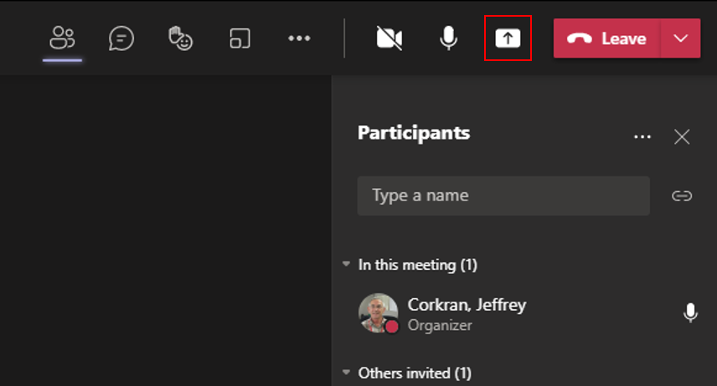
2. | After selecting the share content button, you receive another view showing options for sharing at the bottom of your screen | 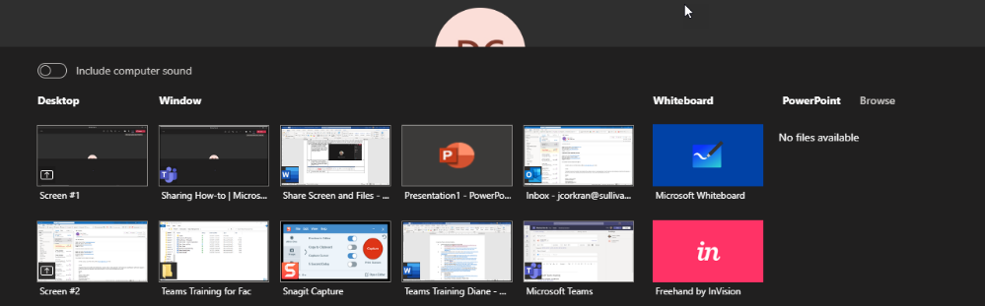
3. | Select Microsoft Whiteboard to use the whiteboard feature. | 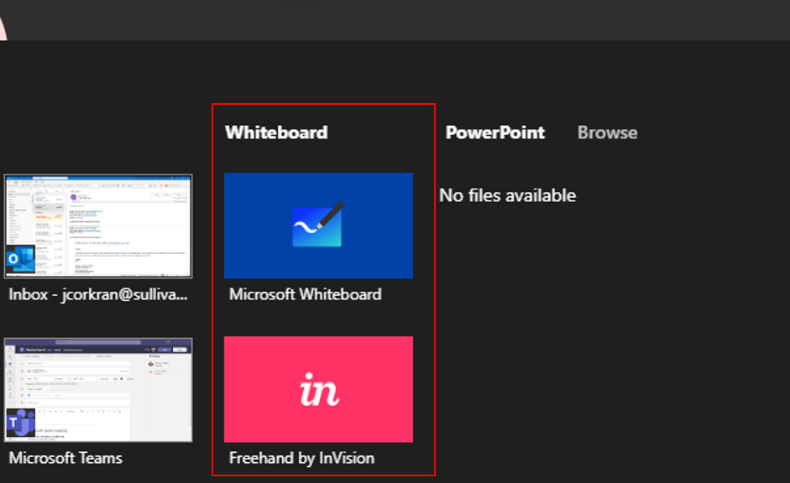
4. | When you select Microsoft Whiteboard, the whiteboard app appears on your screen. | 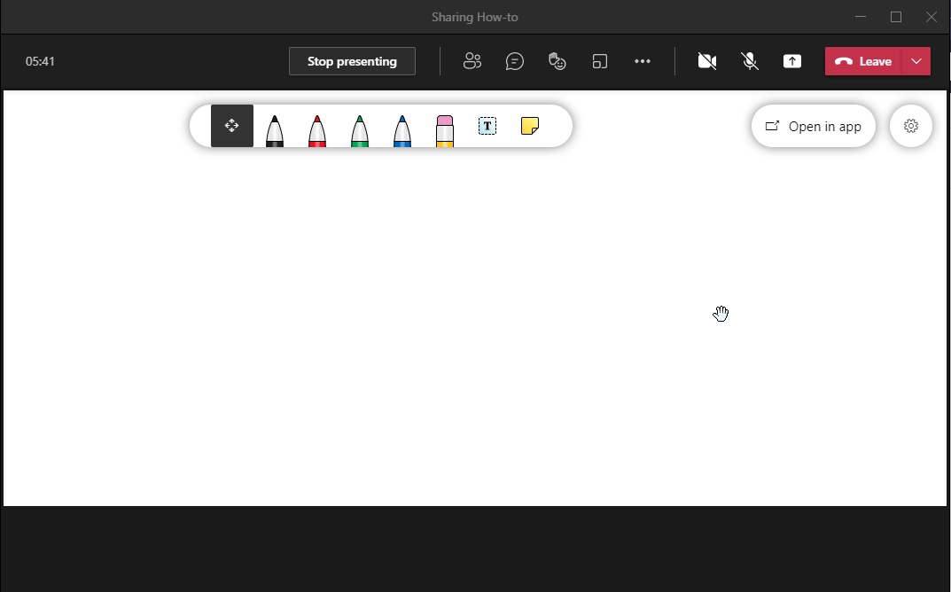
5. | Selecting the settings in the upper right corner of the whiteboard allows you to modify settings for your whiteboard session. | 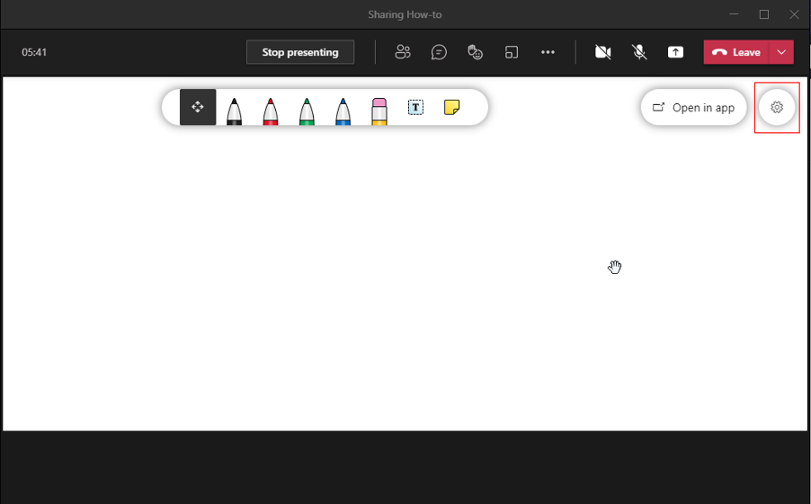
6. | Settings allow you to export the image file, allow others to edit the whiteboard image, and several other actions, as shown in the illustration. You may choose your settings before beginning the whiteboard session or during the session. | 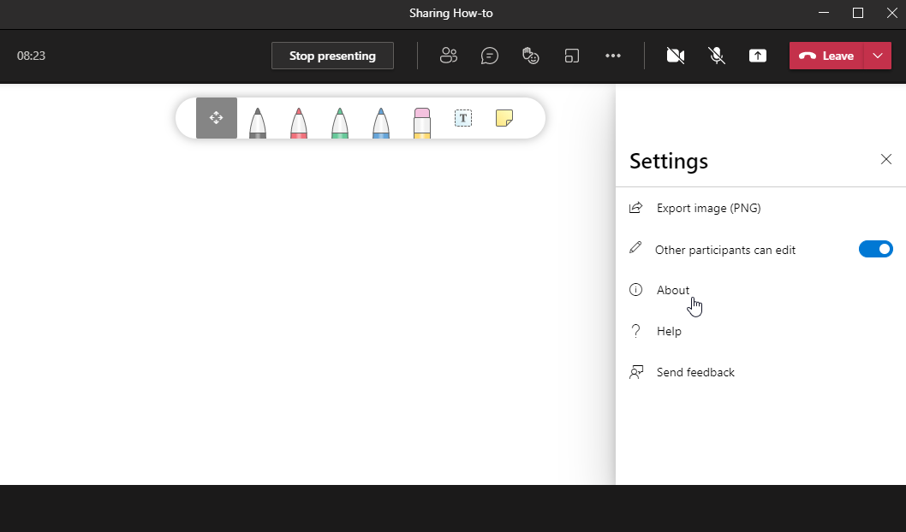
7. | The tools indicated at the top of the whiteboard window allow you to choose what you want to do. The name of each tool displays by hovering your cursor over it.  Colored pens: You may select a colored pen by clicking it. You then use your mouse to draw or write freehand.  Eraser: Choose the pencil eraser to delete/erase anything you have put on the whiteboard. Note that you need to click anywhere on an object you have placed there to erase the entire object.  Add text: This allows you to add a text box within the whiteboard. Once added, text may be moved by clicking and dragging. It can be deleted by selecting the textbox and pressing delete of by deleting it with your mouse.  Add note: Similar to the add text, this adds text in a text box with a colored background, similar to a sticky note. The note may be moved by clicking and dragging and deleted in the same manner as a text box. | 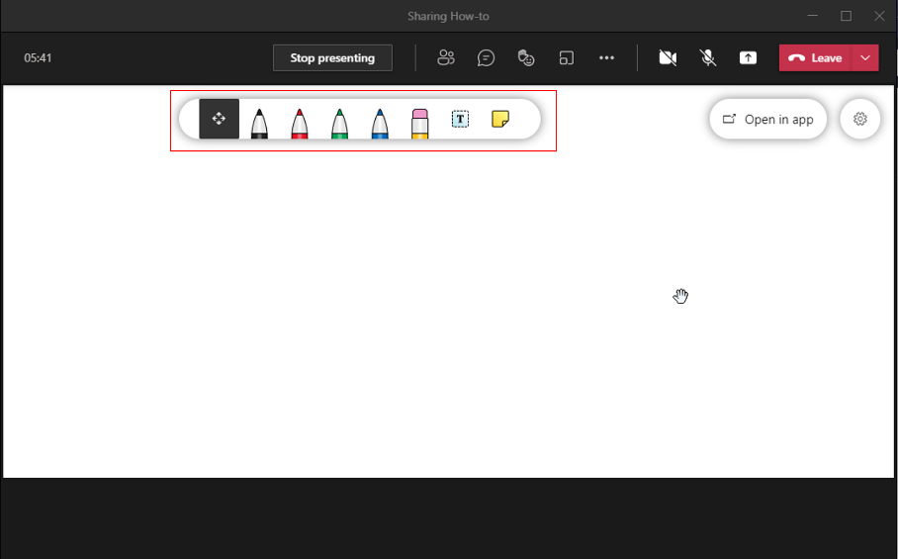
8. | When you have finished with the whiteboard, select the Stop presenting button at the top of the window. | 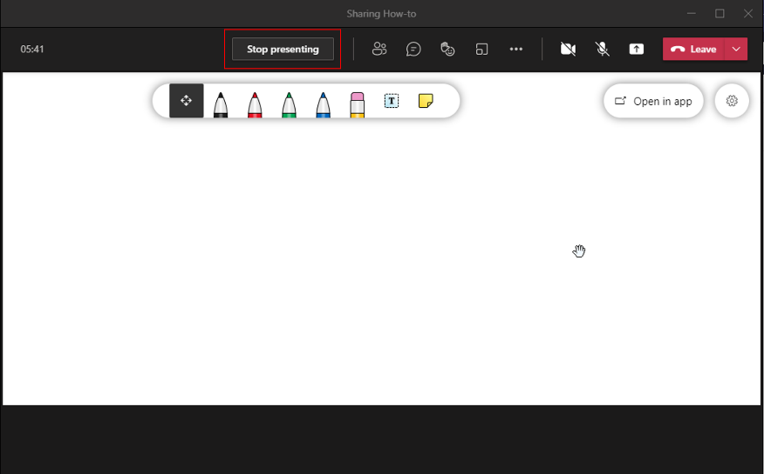
NOTE: If you are recording your Teams meeting, the whiteboard will not be recorded. However, it is available to all participants from the Teams meeting chat, in a tab labeled Whiteboard.
For more on how to use Microsoft Whiteboard, go to https://support.microsoft.com/en-us/office/use-whiteboard-in-microsoft-teams-7a6e7218-e9dc-4ccc-89aa-b1a0bb9c31ee?ui=en-US&rs=en-US&ad=US

