Step | Action | Graphic
NOTE: If you want students or others in the meeting to be able to share content, you must designate them as Presenters. You may do this when you organize the meeting or you may change their status during the meeting. Attendees do not have the capability to share content. See the job aid on managing participants for more information.
1. | Once in the meeting, to begin sharing your screen or files, click the Share content button in the upper right corner of the meeting window, to the left of the Leave button. | 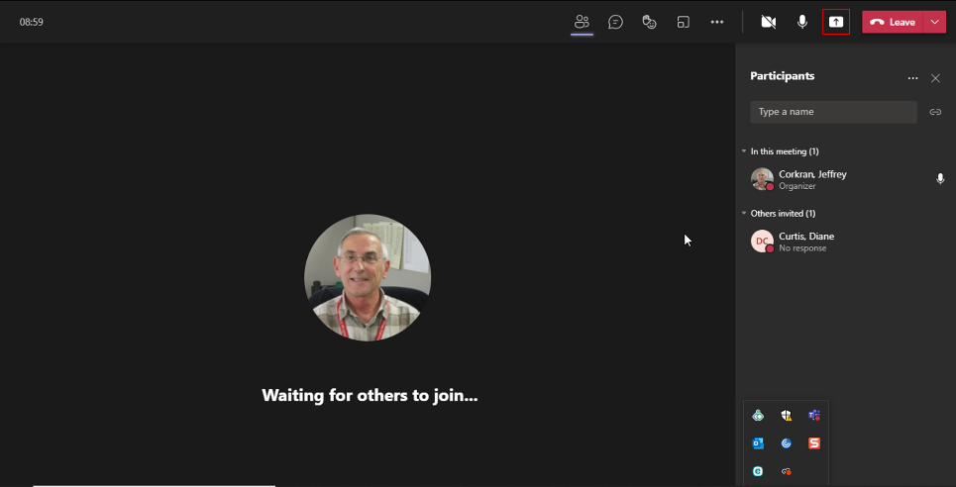
2. | Clicking the Share content button will present you with different options at the bottom of your screen, as shown. | 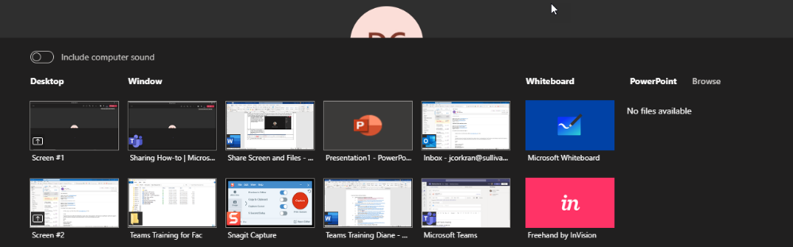
3. | You may share your desktop… | 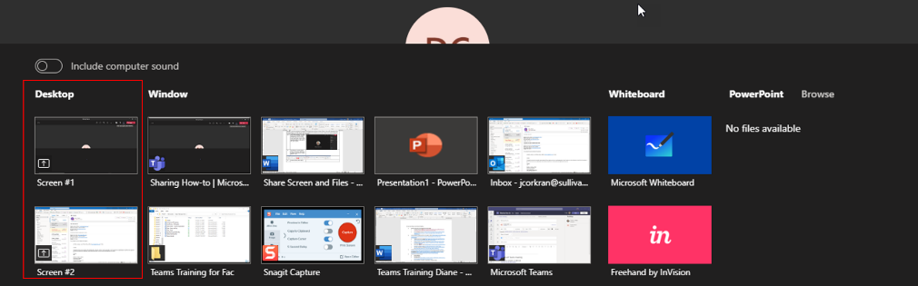
4. | …a particular window… | 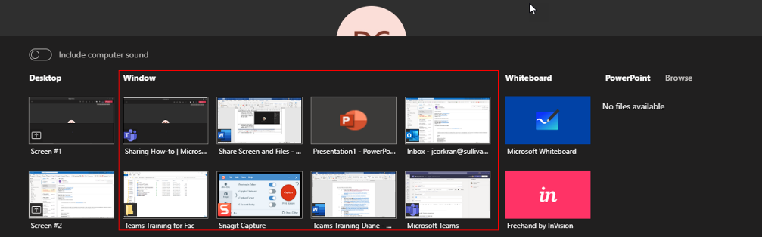
5. | …use the Whiteboard…  (See the separate job aid for how to use the whiteboard feature.) | 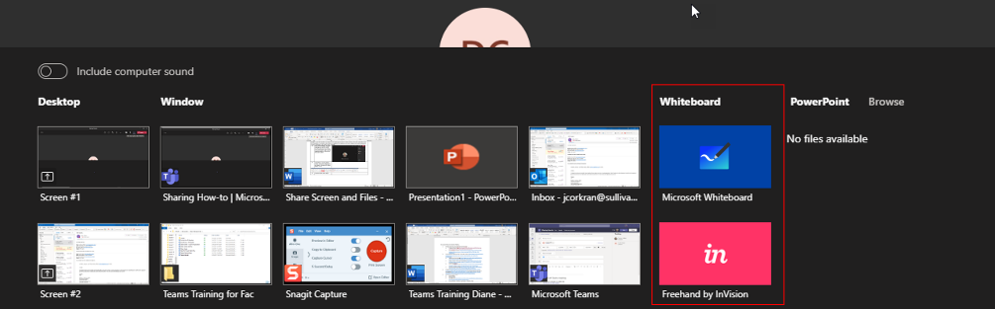
6. | …or share a PowerPoint presentation. (Note that this image shows “no files available” but PowerPoint does show in the Window section.) | 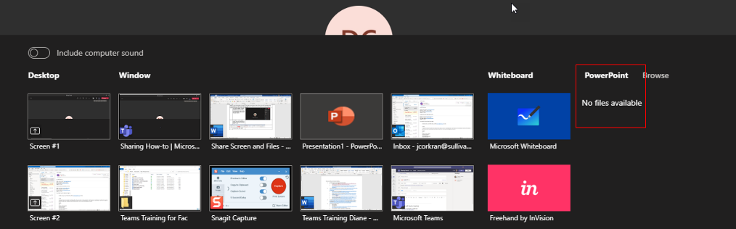
7. | You may also browse your computer for a specific file. Just find the file you want and select it. | 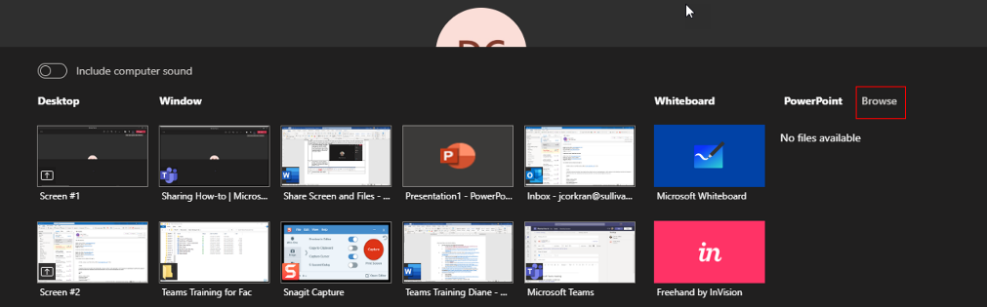
8. | Selecting the Browse link offers you the options of uploading from your local computer or OneDrive. | 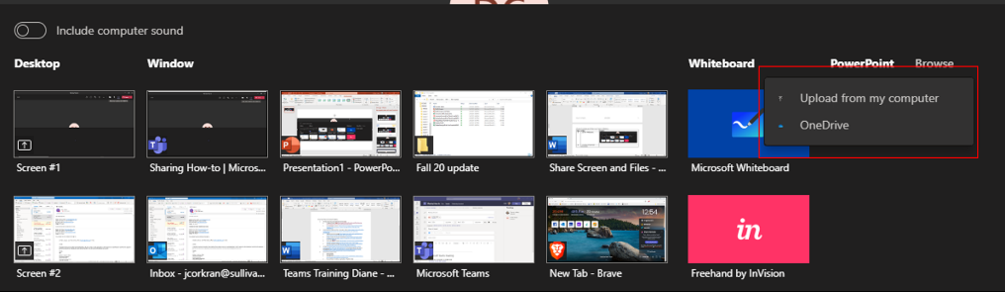
9. | Once you select Upload from my computer or OneDrive, you will see your Windows File Explorer. You may search your drive for the file you want and select it. | 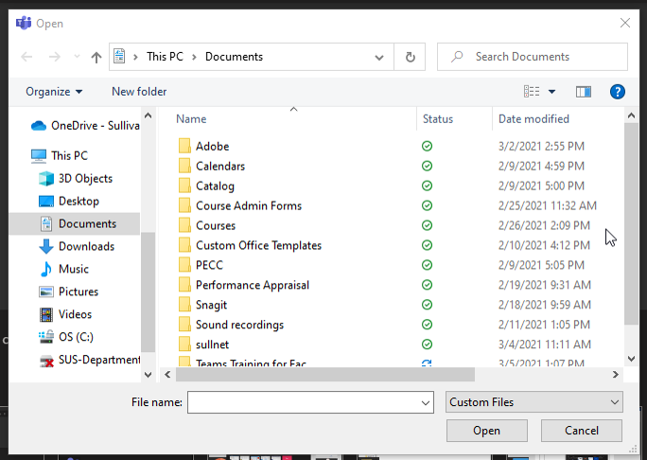
10. | You may also share your computer audio by turning on the Include computer sound switch. Note that this switch toggles the sound – use the same switch to turn off your sound. | 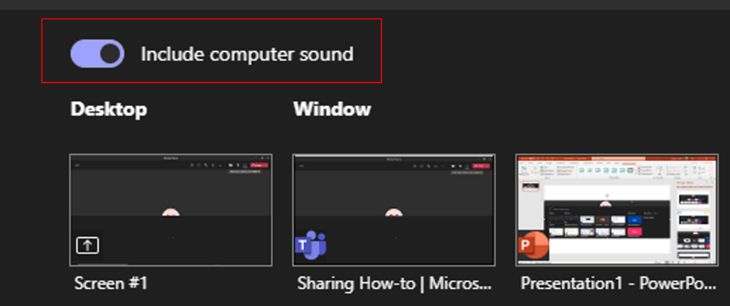
11. | When you are finished sharing what you want to share, select the Share content button again and Teams will stop sharing your screen and/or files. | 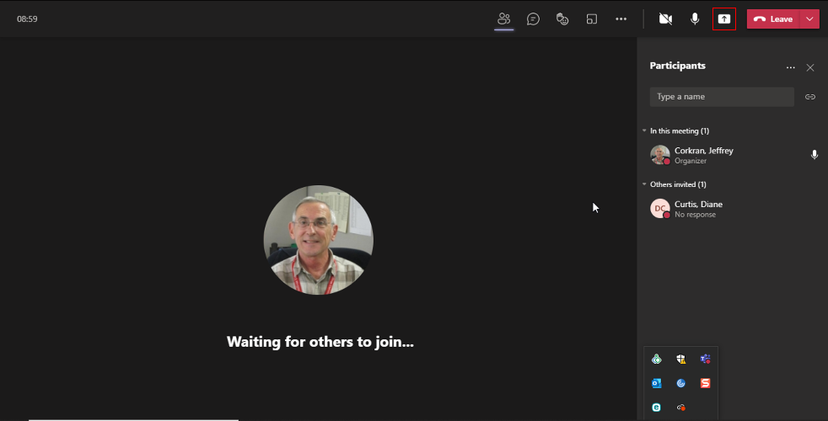
For more information on sharing in Teams, see this Microsoft website, which includes a short video.
For more information on using the Whiteboard, see this website.

