Setting Up to Record Teams Meetings in Panopto
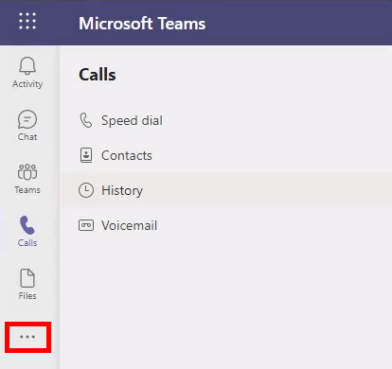 | To add the Panopto application to Teams, open Teams and  Select “More Added Apps” (the 3 dots from the left-hand navigation).
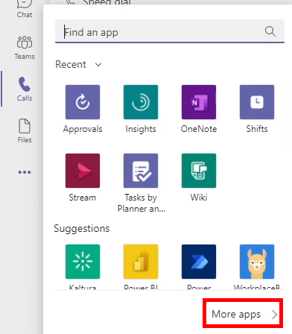 | Select More apps from the window that appears.
Select Panopto
and select Add.
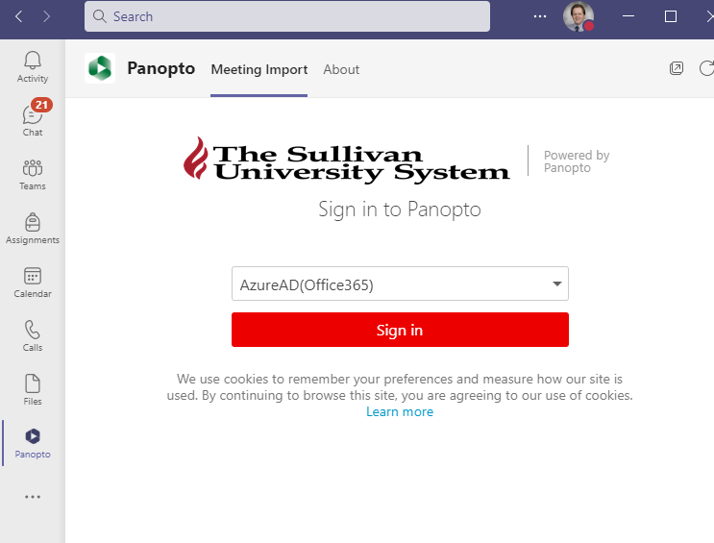 | The Panopto app will now be visible on your left navigation. If you do not see it, expand the window.  When you click the Panopto app, you may be prompted to sign in to Panopto. Select AzureAD/Office365 and enter your password if prompted.
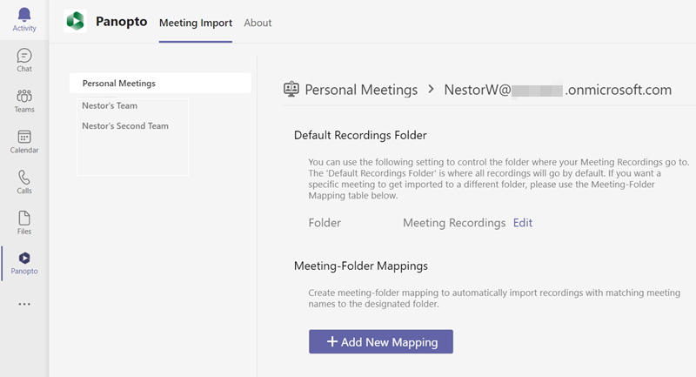 | You should now see the Panopto window showing the Panopto folder where Teams Meetings are stored.  In this case, Teams meetings are stored in “Meeting Recordings.”  If you are OK with recordings being saved to this folder, you are done. If you wish to change the folder, continue.
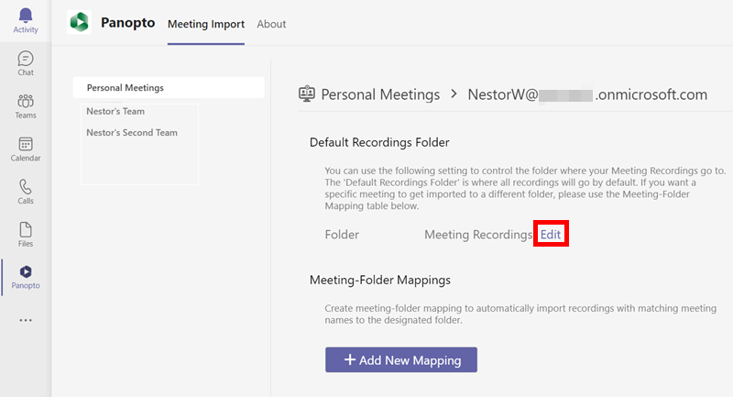 | If you wish to change the folder where recordings will be stored, select Edit.
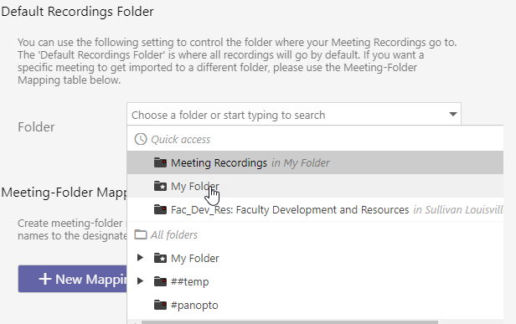 | Pull down the menu and select the desired folder.
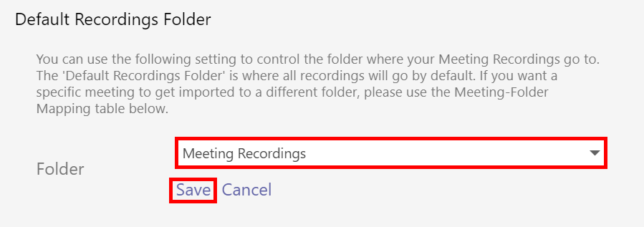 | Select Save.

