Step | Action | Graphic
1. | To raise your hand during a meeting, hover over the Show Reactions button in the meeting controls and choose Raise your hand. Everyone in the meeting will see that you have your hand up. | 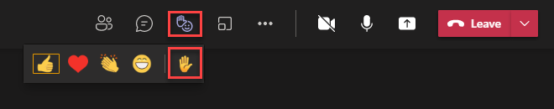
2. | You can also use Show Reaction to express yourself in your meeting. Hover over the Show Reactions button to choose one of four live reactions: Like, Love, Applause, and Laugh. Your reaction appears for a few seconds in your live video feed or on your profile picture. If you or someone else is sharing content in a meeting, reactions will float up from the bottom of the screen for a few seconds. Corresponding reactions also appear on the profile pictures of participants who send reactions. | 