Change Participant Roles Before a Meeting
Step | Action | Graphic
1. | Once you have created a Teams meeting in your Outlook calendar and sent out the meeting invite, click on the meeting you just created, and select Meeting options. | 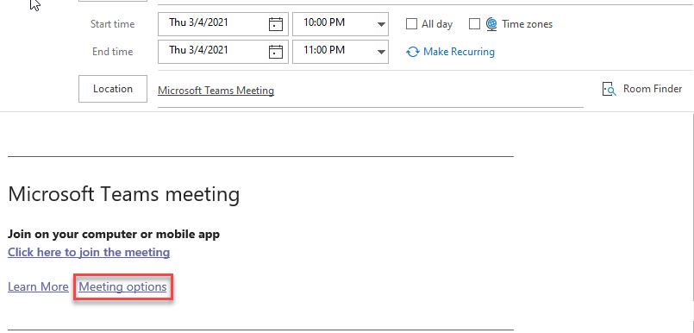
2. | Click on the arrow across from Who Can Present to access the pull-down menu. Choose who can present during the meeting. The chosen person/people will join the meeting as a presenter.

Change Participant Roles During a Meeting

Method 1
Step | Action | Graphic
1. | During a meeting, you can access the meeting options listed above by clicking on the three dots to access More Actions and choosing Meeting Options. | 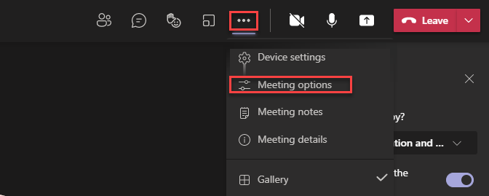

Method 2
Step | Action | Graphic
1. | Click Show participants in the meeting controls to see a list of all the people in the meeting. | 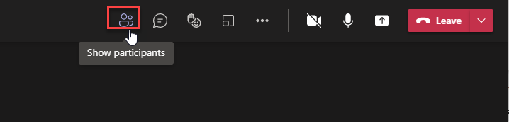
2. | Click the three dots next to the name of the person whose role you want to change and select Make a presenter or Make an attendee. | 