Mute/unmute Participants Before the Meeting
Step | Action | Graphic
1. | Once you have created a Teams meeting in your Outlook calendar and sent out the meeting invite, click on the meeting you just created, and select Meeting options. | 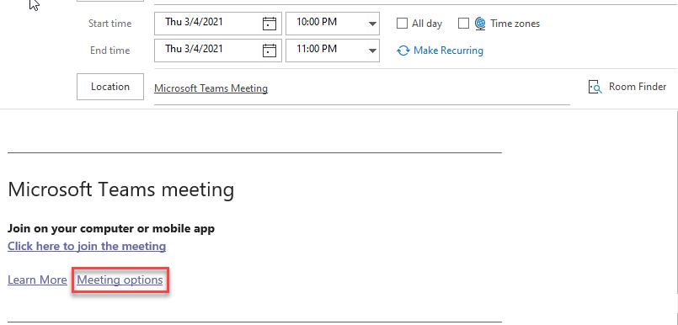
2. | Choose Yes or No for Allow Attendees to Unmute.  Choosing Yes allows participants to unmute their microphones during the meeting. Attendees are not muted when they join the meeting.  Choosing No turns off the microphones so that attendees cannot unmute themselves during the meeting. All attendees (but not presenters) are muted when they join the meeting. | 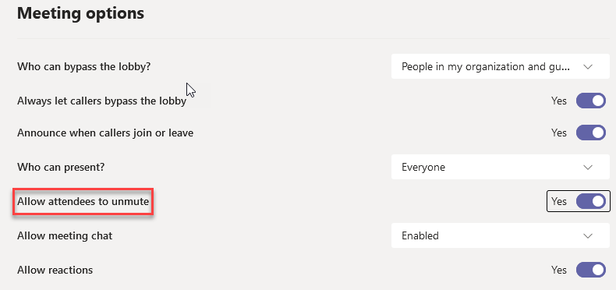

Mute/unmute Participants During the Meeting
Step | Action | Graphic
1. | To mute all participants in the meeting, click on Show Participants. A Participants panel appears on the right. | 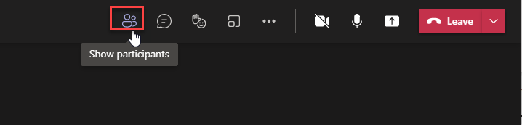
2. | In the participants panel, click Mute All. A prompt appears: "Mute everyone? This will mute everyone in the meeting but you." Participants receive a notification that they have been muted. | 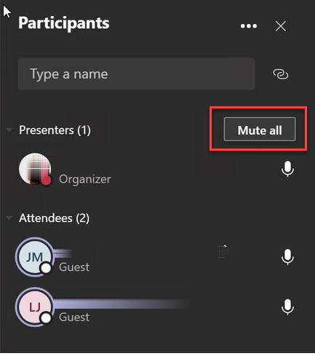
3. | To mute certain participants, from the participants panel, click the three dots next to the name of the person you want to mute and choose Mute. To unmute the individual, click the three dots and choose Unmute. | 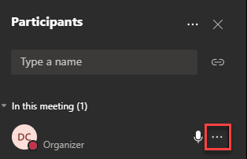
4. | To prevent attendees from unmuting, select the three dots next to Participants in the Participants panel and choose Don’t Allow Attendees to Unmute. | 