Step | Action | Graphic
1. | When you open your Teams meeting, you have several tools and buttons along the top bar of the Teams window. This document addresses the more actions selection (the ellipsis). | 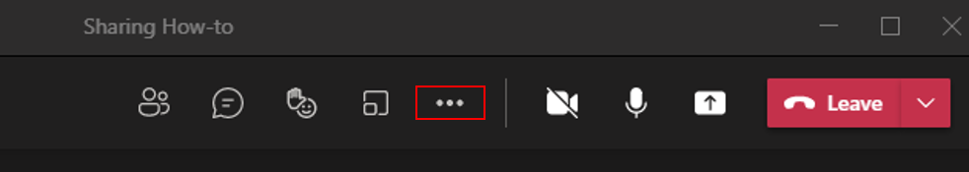
2. | When you click on the more actions ellipsis, Teams shows you a drop-down menu with a number of choices. You may then select which of the choices you need. | 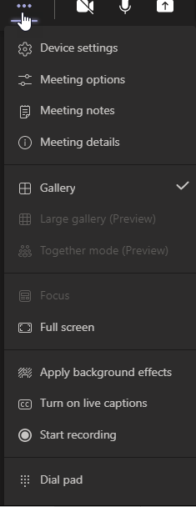
3. | Device settings allows you to use your computer’s devices properly. | 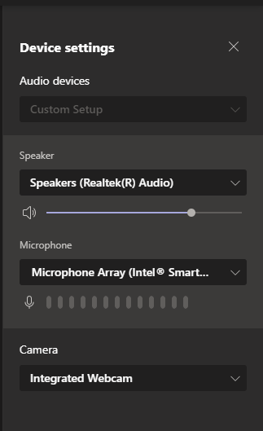
4. | Use Meeting options to customize details of how you will conduct your meeting. The illustration is of the Teams default.  See the Meeting Options job aid for more information. | 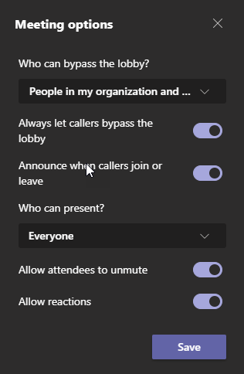
5. | The Meeting notes selection brings up another drop down. Selecting the Take Notes button on this drop down brings up a page where you may take notes (not shown). These notes stay with the meeting for all attendees to access. Selecting the X in the upper right of this window hides (turns off) the meeting notes. In the more actions menu, you may also hide meeting notes. | 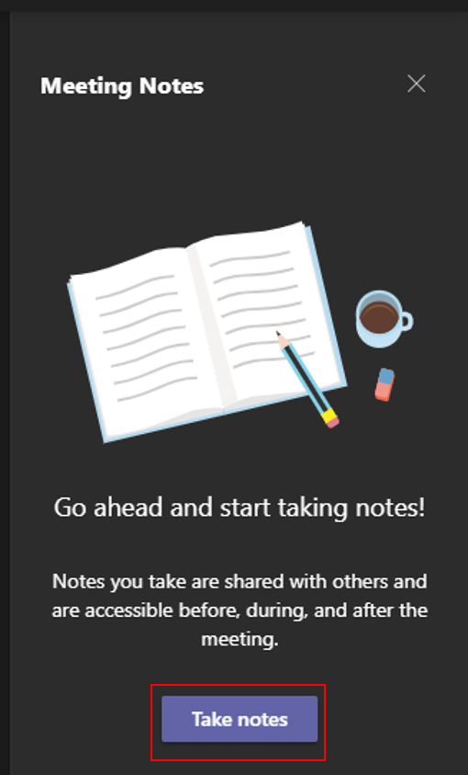
6. | The Meeting info selection displays the details of your meeting and provides a link to join. This link will show hide meeting details if it is turned on. | 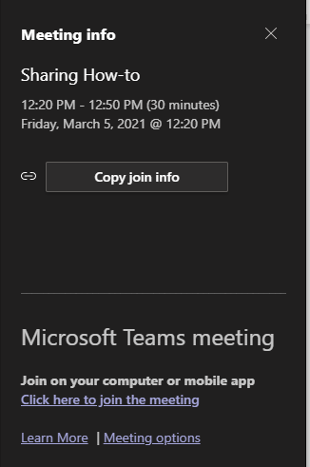
7. | The next section of the more actions drop down controls how you see others within the meeting.  Gallery shows up to 9 participants in a grid and is the default view for Teams.  Large gallery shows up to 49 people in a grid. It is only available when at least 10 attendees have their cameras turned on.  Together mode shows all attendees who have their cameras on as if they are together in the same space, such as in the illustration here. This mode includes different scenes, so have fun! Just pick a scene and click Apply. This view becomes visible to everyone in the meeting. | 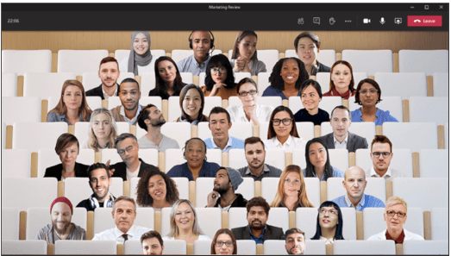
8. | The next section of the more actions menu allows you to control how your computer sees the meeting.  Focus allows you to focus on content when it is being shared. If no content is being shared, this is not an option.  Full screen enlarges the Teams window to fit your screen. Exit full screen by pressing escape. | 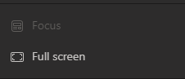
9. | Next is the section of the menu that enables you to change how you appear to others.  Apply background effects lets you pick from a number of different backgrounds that are superimposed behind you when you are using your camera. These change how everyone in the meeting sees you.  Turn on live captions allows Teams to generate text closed captions at the bottom of your screen. These captions only appear on your screen and each participant must turn the feature on individually. This menu selection changes to turn off live captions when it is turned on.  Start recording starts recording all audio and video of your meeting, which is available for viewing later. You must turn off recording when you are done. | 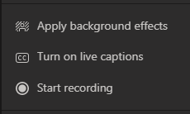
10. | The final section of the menu allows two actions:  Dial pad is used to dial outside numbers. In Sullivan University, this works only with SU numbers.  Turn off incoming video turns off all incoming video and you see only the Teams screen. | 