Send a Chat to All Attendees
Step | Action | Graphic
1. | To access the Chat in your Team meeting, click the conversation button. The Meeting Chat opens on the right side of the screen. Enter your text in the text box at the bottom of the Meeting Chat window. | 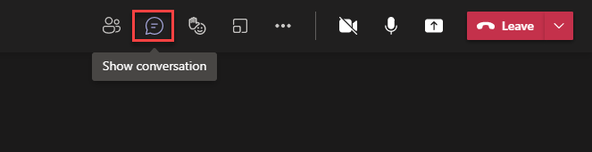  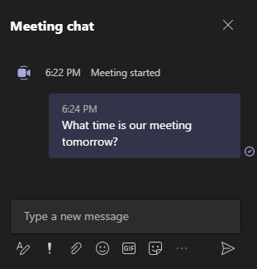
2. | Click the Format button to expand the text box and bring up text formatting options. | 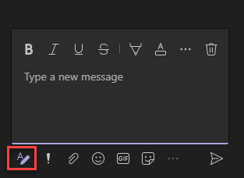
3. | You can set the delivery options by clicking on the exclamation point. | 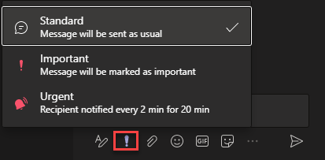
4. | You can attach a file from your computer or OneDrive by clicking on the paperclip. | 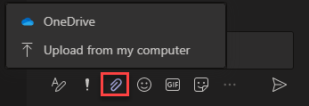
5. | You can add an emoji to your message by clicking on the emoji button. | 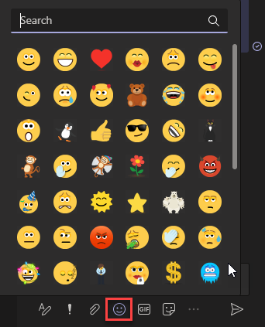
6. | You can add a GIF to your message by clicking on the GIF button. | 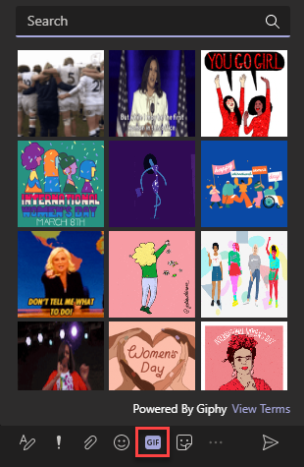
7. | You can add a sticker to your message by clicking on the Sticker button. | 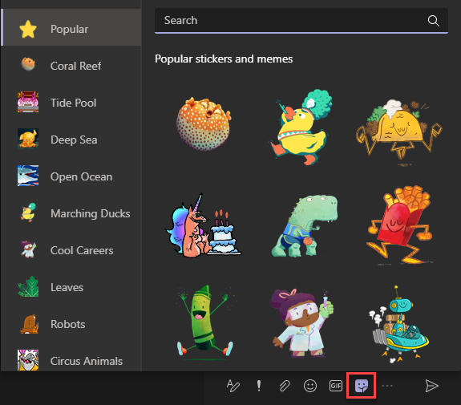
8. | Click on the three dots to choose from a list of available apps. | 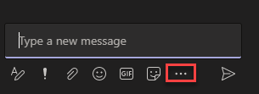  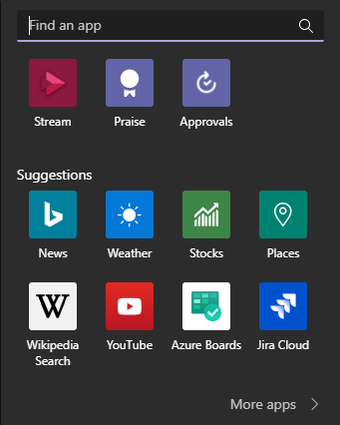
9. | When you are finished composing your message, click Send or hit Enter on your computer keyboard. | 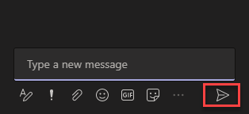
10. | After posting your message, you can edit it or delete it. Hover over the message and click the three dots to access the message options. | 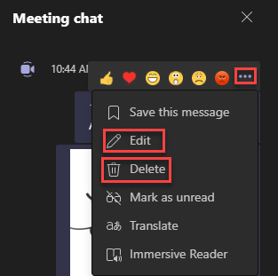
11. | To close the Chat window, click the conversation button. | 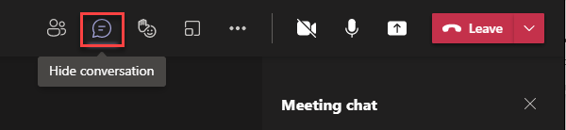

Send a Private Chat
Step | Action | Graphic
1. | Hover over the image of the person you want to send a message to and a window appears that allows you to send a message to that person. | 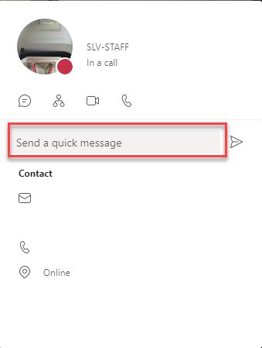

Chat Options
1. | Hover over a message to bring up the options. You can choose an emoji to react to the message. | 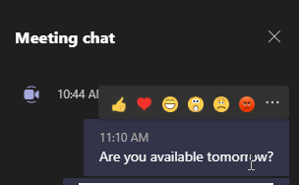
2. | Click on the three dots to access options for the message. | 