How to Record a Video with Closed Captions Using Panopto

1. To create a video click the Create drop down and select Record a new session. | 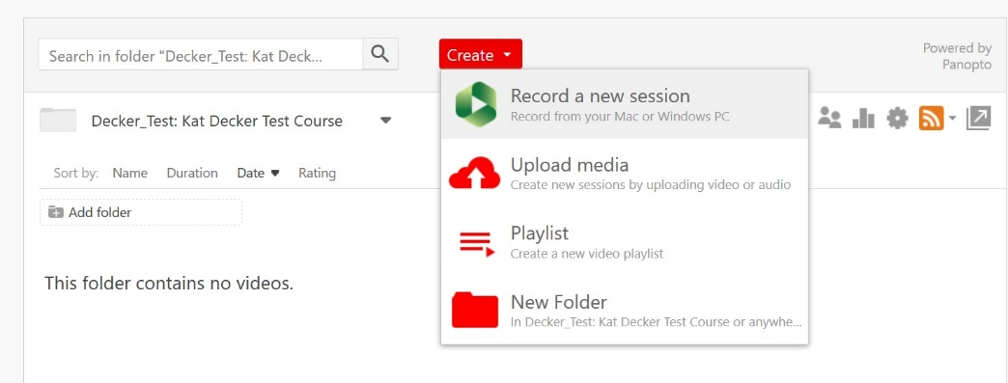
2. The folder you are in is identified, and the name, by default, is the Date and Time. (There is a Tour available if you wish to view. If not, select Skip Tour.)  You may use the drop down arrow to find the right folder if by some chance you are not in the correct folder.  You may edit the name of the video at this time.  Note that you are within a designated area of Panopto called Create New Recording (blue highlight). You can toggle within these areas as required. | 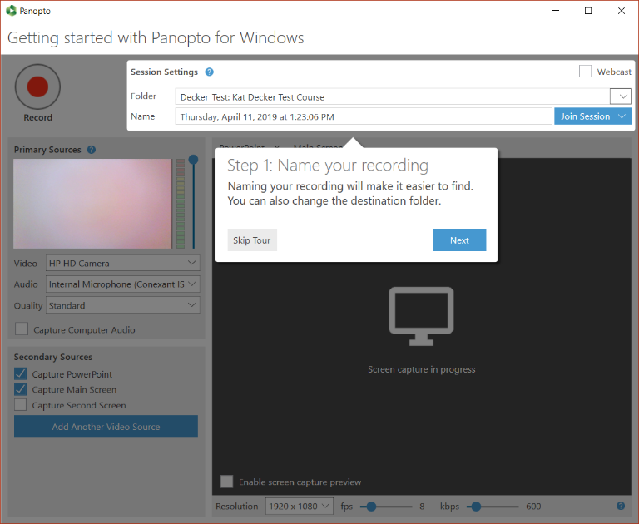  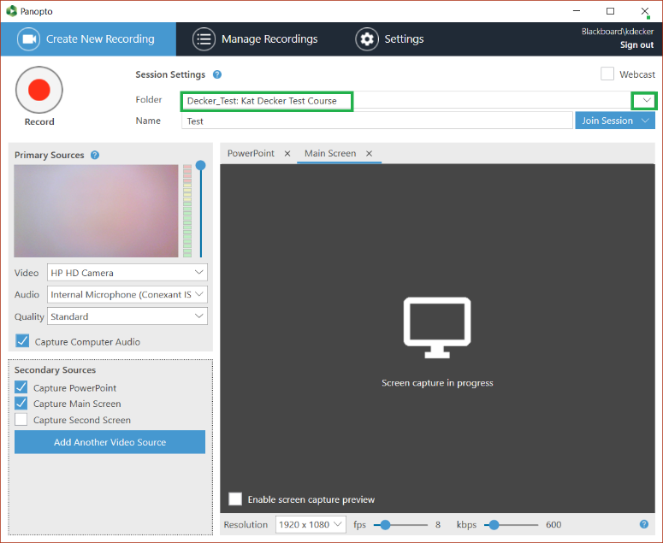  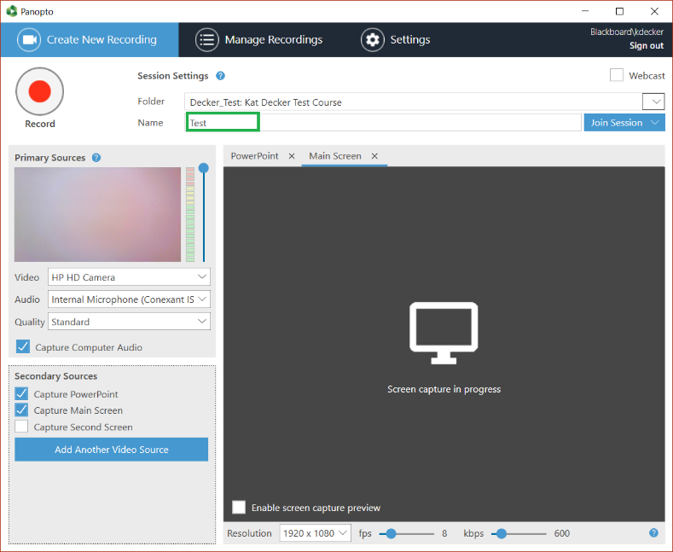
3. Now you need to check settings. These Primary Sources settings are the default and should be left as is. | 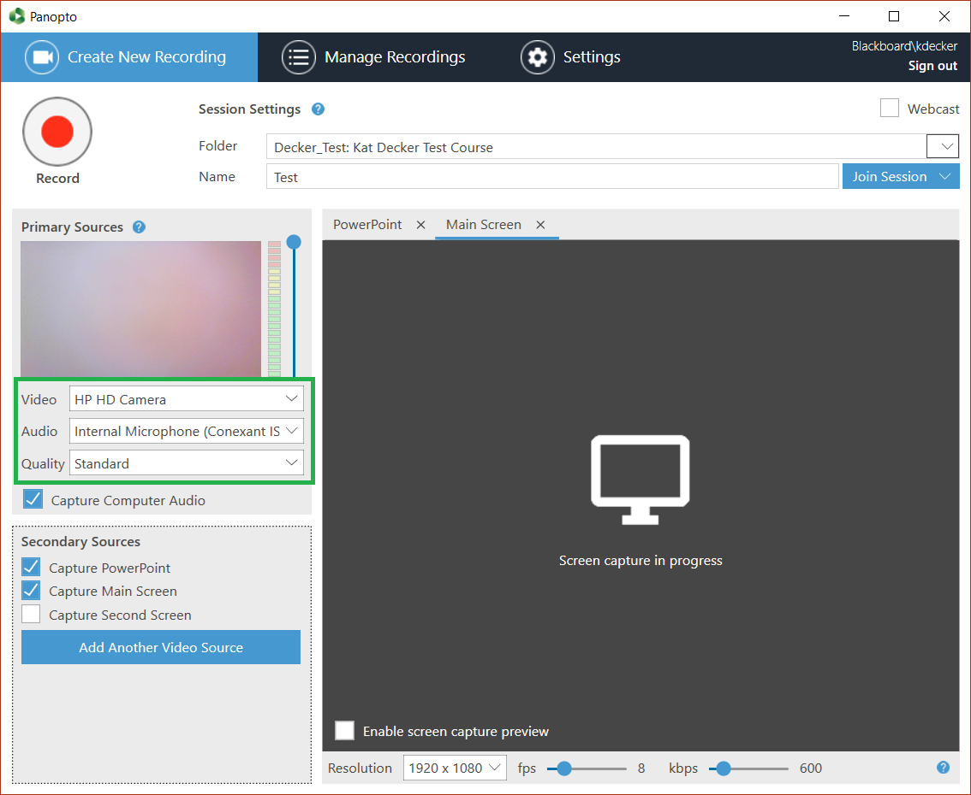
4. Check Capture Computer Audio to turn on captioning. | 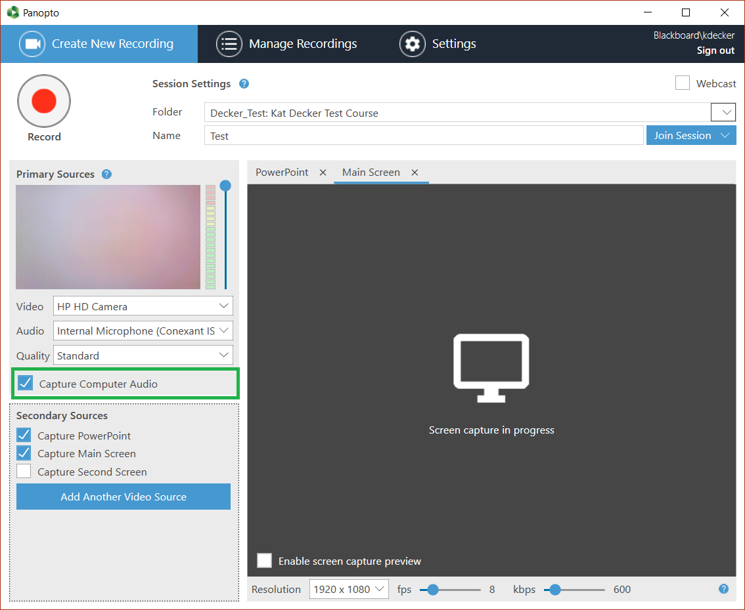
5. Indicate your required Secondary Sources. This is where you can capture slides, a whiteboard application, or a second monitor. | 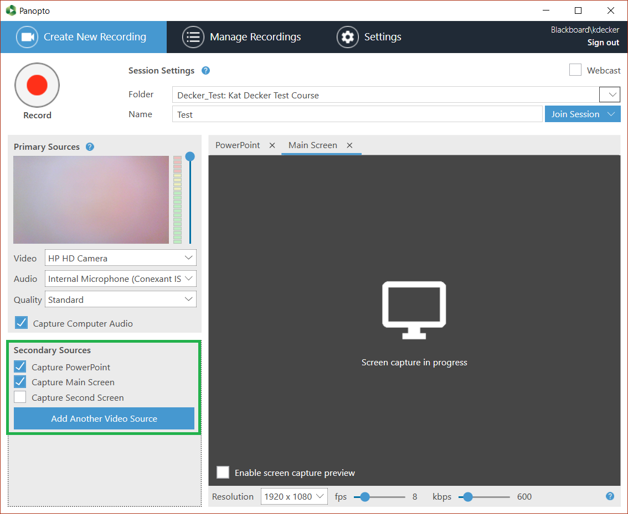
6. In order to verify what is being recorded it is a good idea to check the Enable Screen Capture Preview box before you begin to record. | 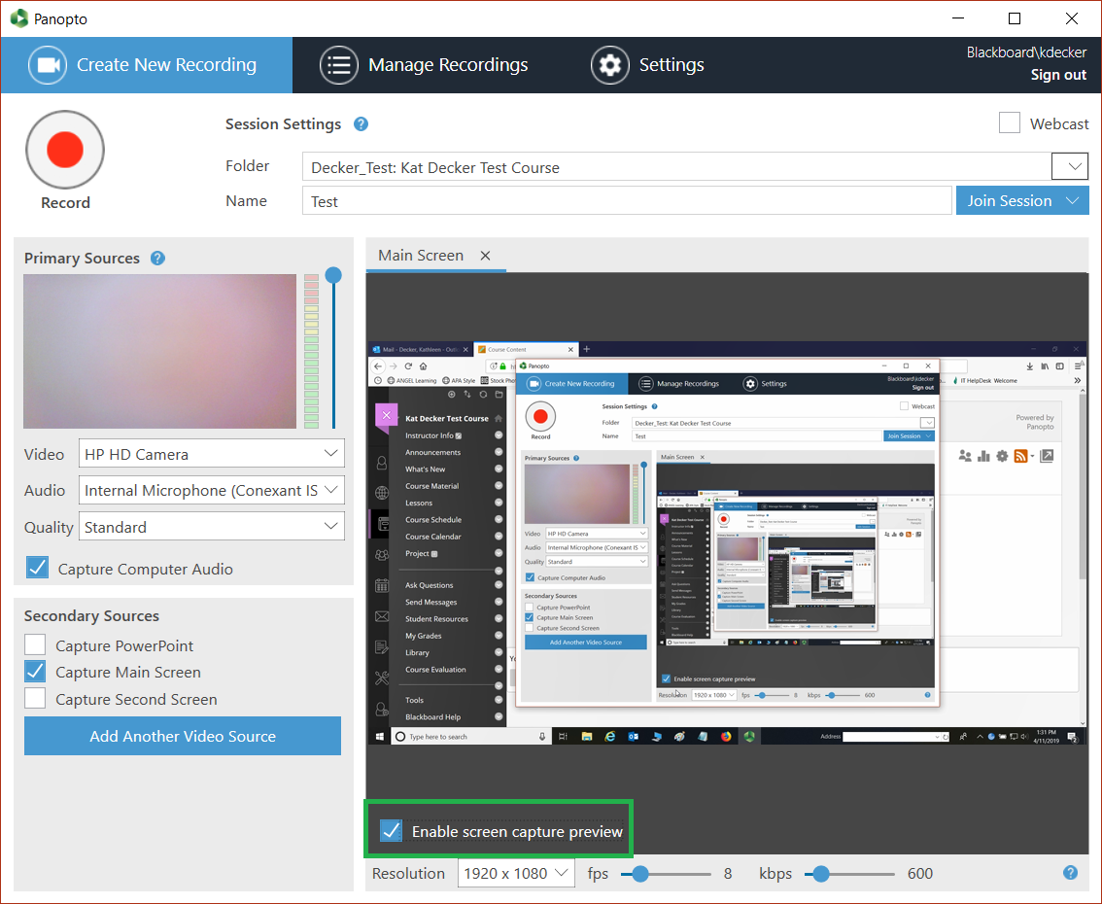
7. Click the Record button and begin your video presentation. | 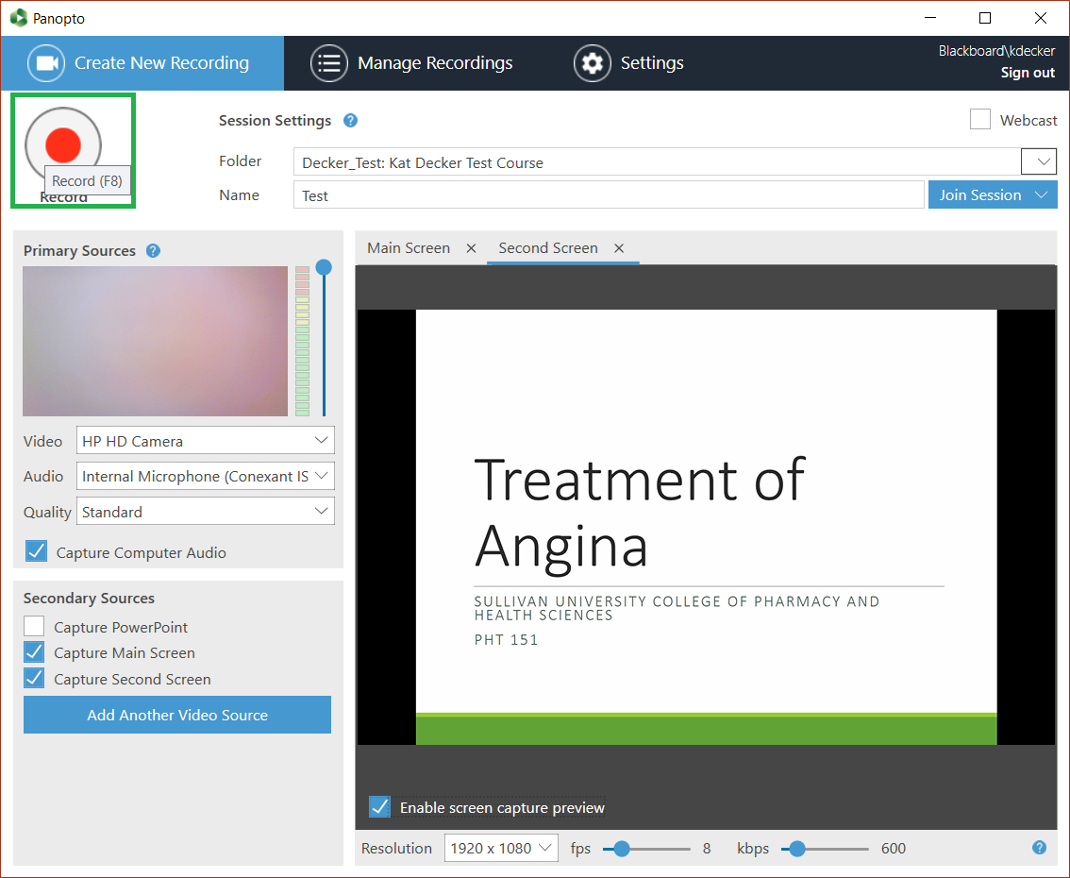
8. You can Pause or Stop as required. | 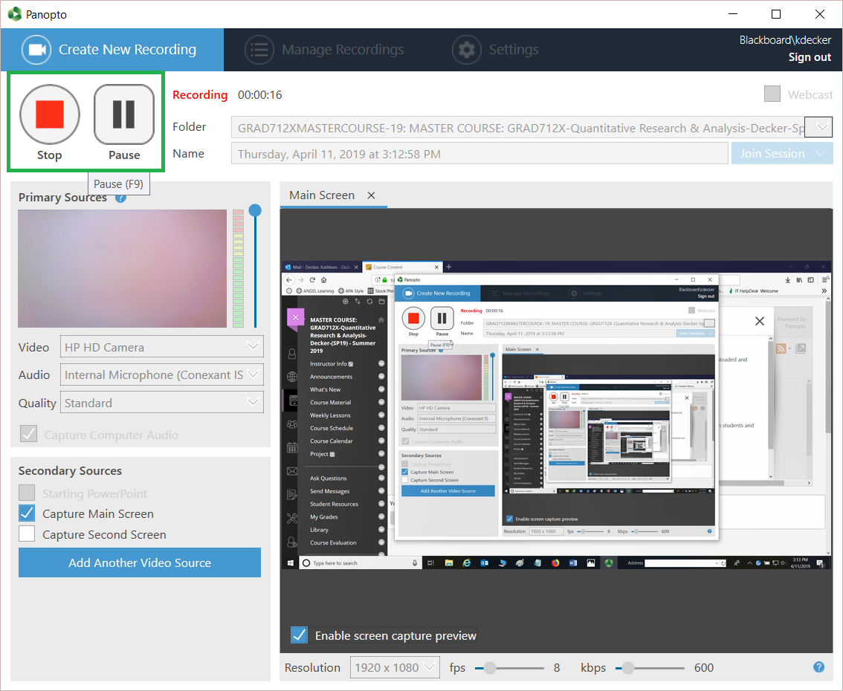
9. Once you stop recording you should see this message. You can select Delete and record again or select Done if satisfied with the recording. You can edit your title and also add a description of the video while on this screen. (There is still further opportunity to edit the video.) | 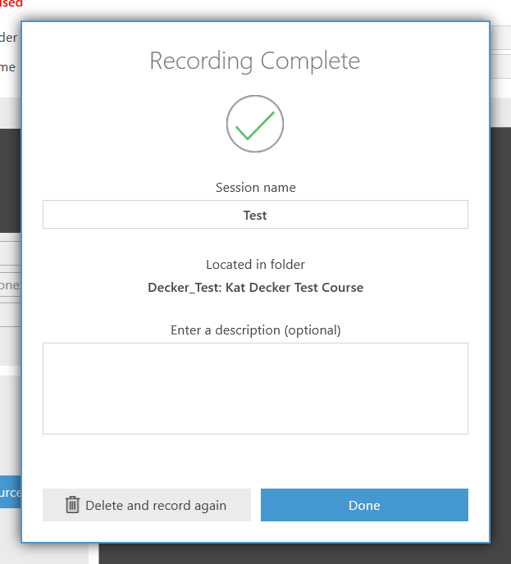
10. Once you select Done you are taken to a screen where you can monitor the rendering process. Note that you are now in the area designated as Manage Recordings (blue highlight).  Once the video renders you can still edit the video. (Note the Edit button that has appeared as the process progresses.) | 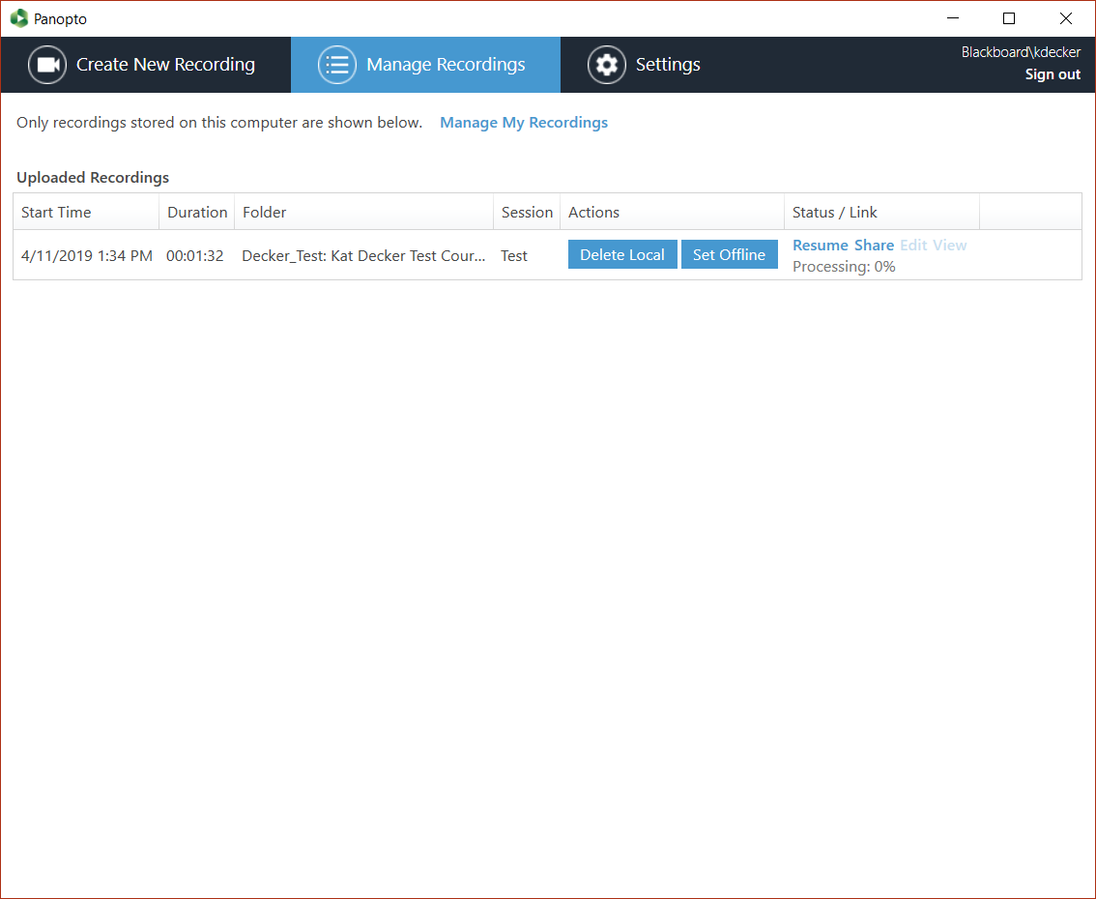  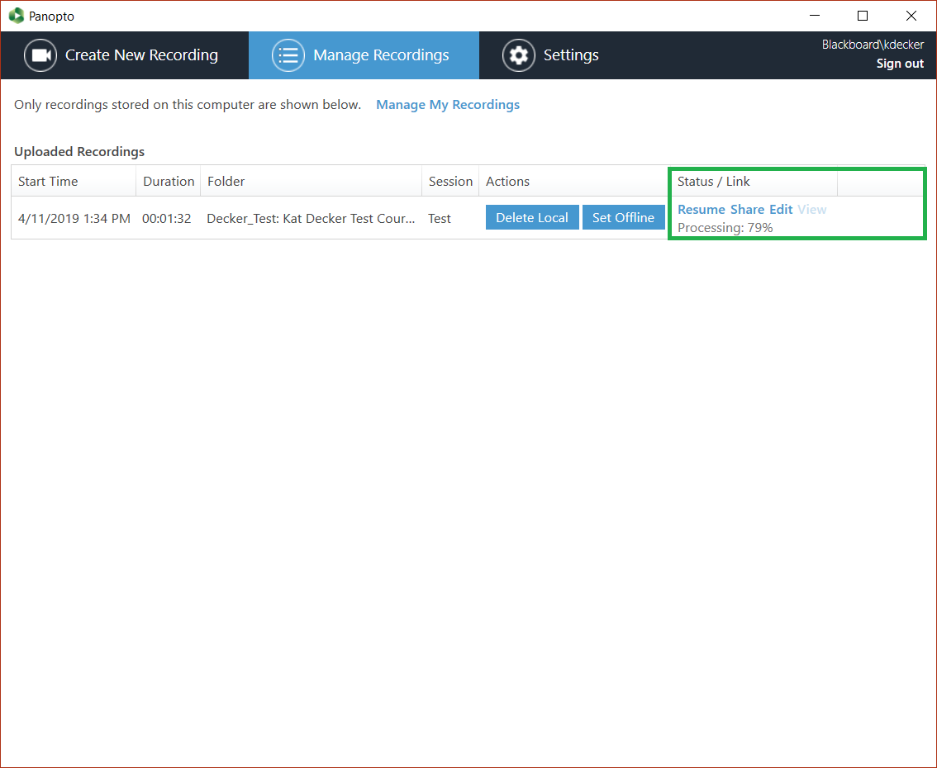
11. You can now edit the content, captions, add or remove slides, insert files, insert quiz questions, etc. | 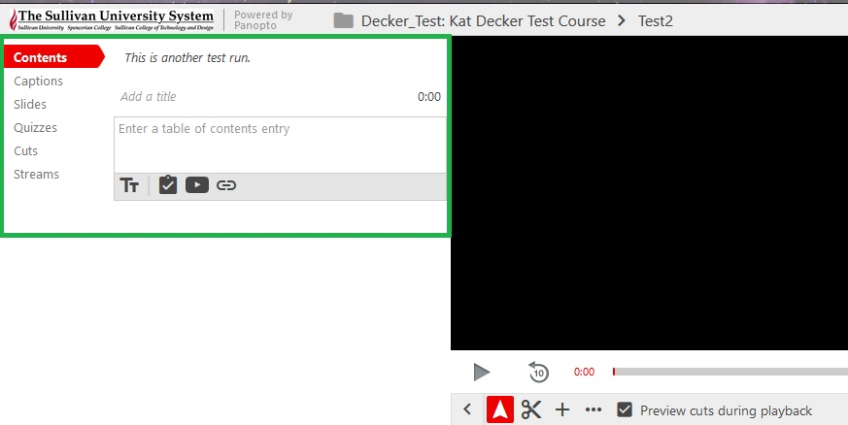
12. While you may not need to edit other items, you MUST edit your captions for complete accuracy.  Select Captions. You have several options for completing your captions.  Though you set your automated caption earlier (in Step 4), you may instead type captions directly into the text box. | 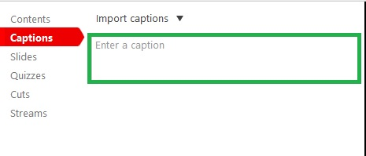
12a. A drop down arrow also appears for you to import/request captions.  Select Import automatic captions.  Note: The recorded captions may take some time to actually appear, but you can edit other things until the captions are present. | 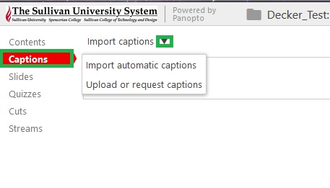
12b. Machine captioning gives you a basis for your closed captioning but it not accurate. You MUST edit your captions for misspelled, missing, or misinterpreted words, missing/wrong punctuation, etc. Looking at this example gives you an idea how inaccurate it may be.  Note: Captioning may not appear right away. It may take time to render. Edit each caption section. | 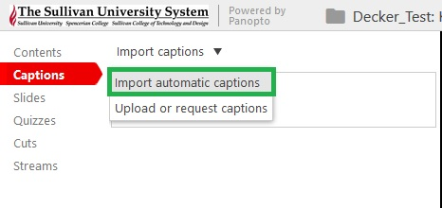  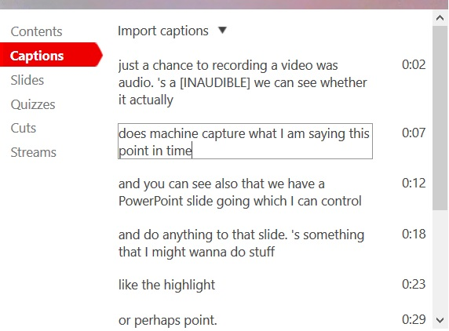
12c. Another caption option is to upload a caption file. We recommend editing the caption file prior to upload. Captions should include text as well as time stamps.  Note that caption files must be in a .srt format. You can create an .srt file using Notepad. | c1.Select Upload or request captions. | 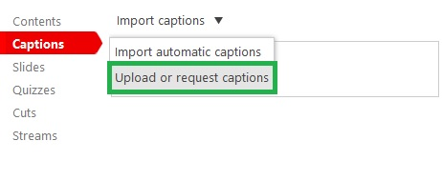
 | c2.You can browse for the file. | 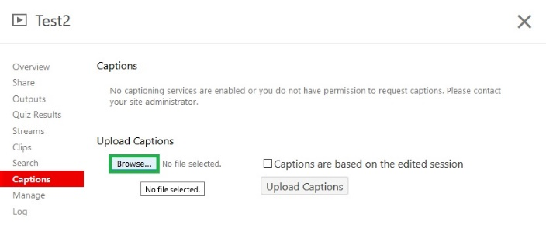
 | c3.Once located select Upload Captions. | 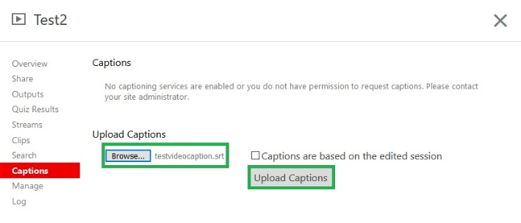
 | c4.You will receive a status update. | 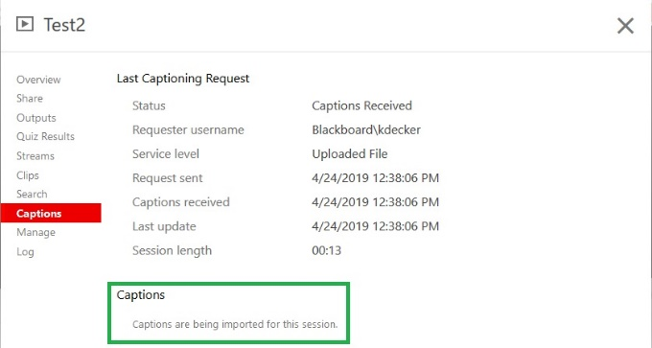
12d. Once you have edited your captions you MUST save/publish your changes! Click the Publish button.  You receive a confirmation your changes have been saved. You may now exit the editor or go back to continue your edits. | 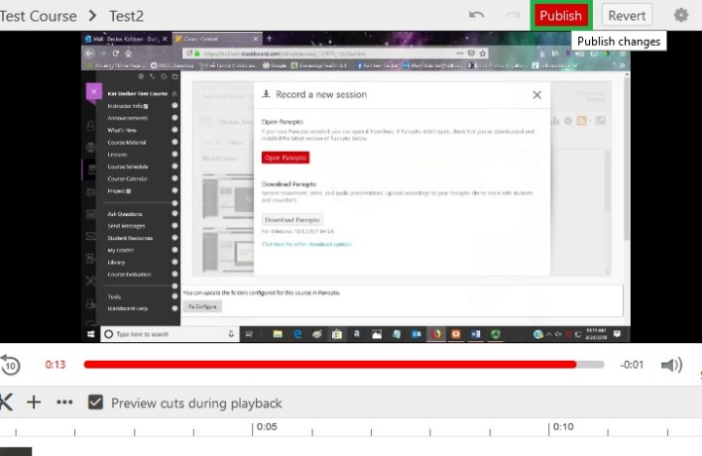  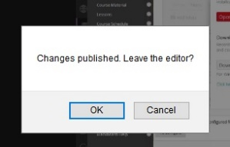
13. Once Published your video should appear in your folder list. | 