Step | Action | Graphic
1. | To move content from one Blackboard course to another Blackboard course, click the chevron next to the content you want to move and select Move from the drop-down menu. | 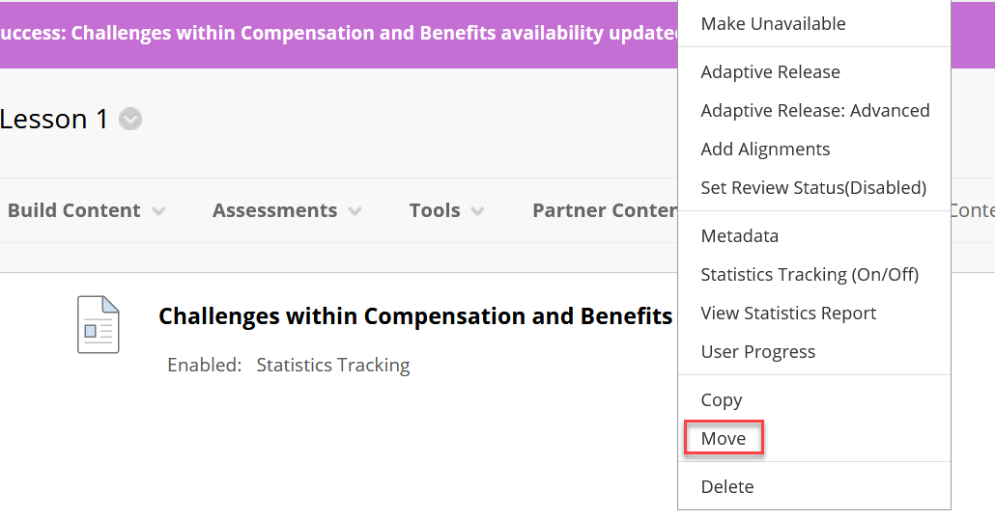
2. | Choose the Destination Course from the list of available courses. | 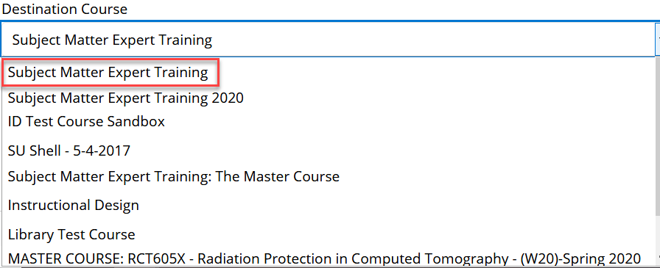
3. | Click on Browse to choose the Destination Folder.
3. | From the list of available folders in the destination course, click on the name of the folder to which you want to move the content. | 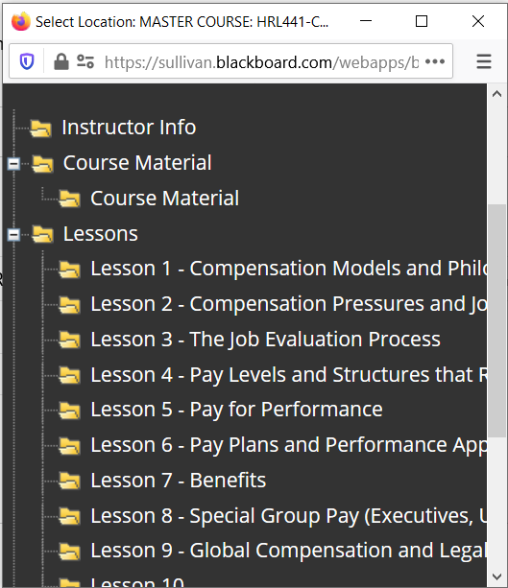
4. | Click Submit.

