For Microsoft Word Documents
Step | Action | Graphic
1. | Use headers rather than formatting manually.  Start with Heading 1 as the topmost defined heading. | 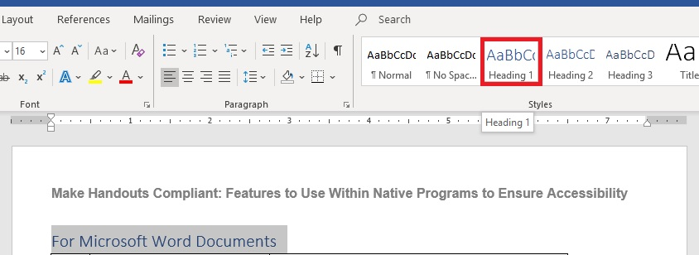
 | Note: Do not skip Heading levels, that is, do not jump from Heading 1 to Heading 4.
2. | Use a Table of Contents for complex documents. | 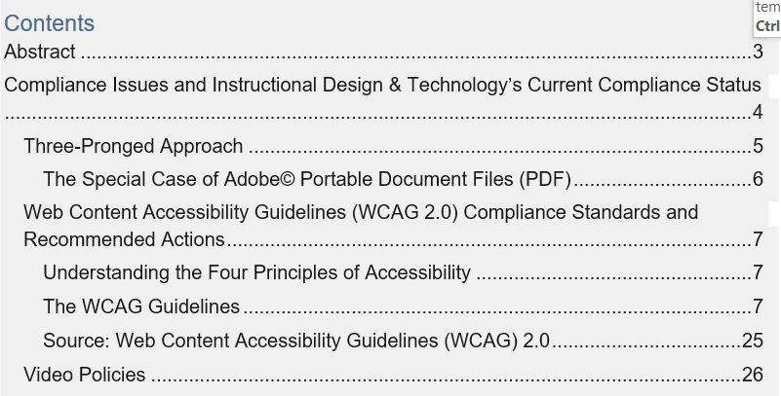
3. | Use a san serif font such as Arial or Verdana.  Body text 10-12 pt.  Use line and a half spacing. | 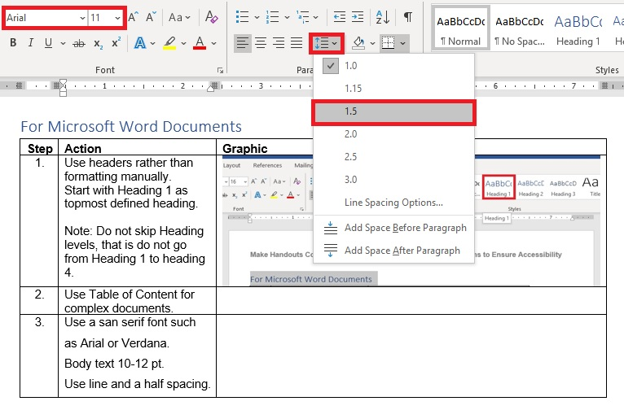
4. | Use Alt Text tags for images. There are two ways to access the alt text field:  a. Right click on the graphic and select Edit Alt Text  or  b. Select Format Picture and go to the ALT Text tab.  Alt text should be  - Short for most images  - Include relevant words if graphic uses words, such as a word cloud or the image of a table | 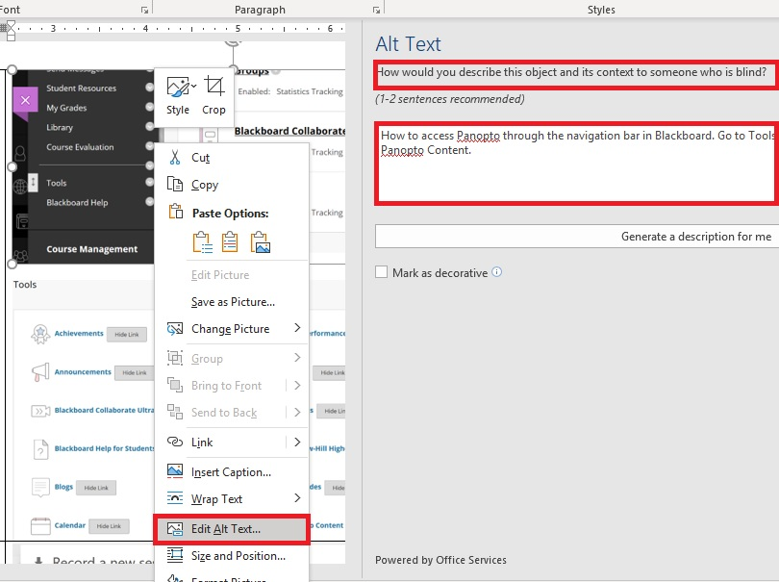  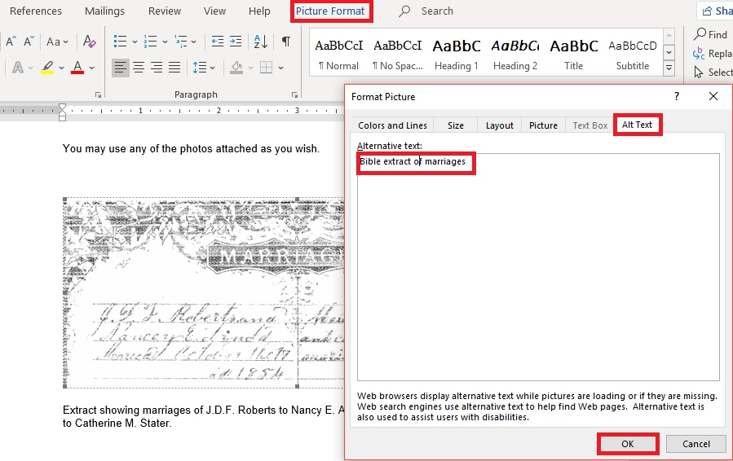
Note:
- A Null value will automatically be used in most instances for things such as clip art, or pictures that are not specifically relevant/decoration only
- For relevant graphics such as charts or graphs, alt text is required
- Not using alt text will cause an error to be reported during Accessibility checking, you can designate that it is a decorative item only
5. | Do one of these for complex graphics:  - Add a long description  - Add an explanation in a doc of ‘explanations’ as an alternate presentation  - Explain above/below the graphic within main document (shown) | 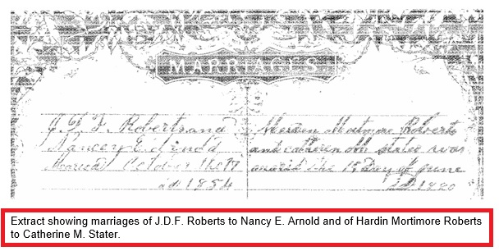
6. | Introduce a table with a text explanation.  - If possible spell out numbers in explanation | Option a. Include text with the table on the base page.  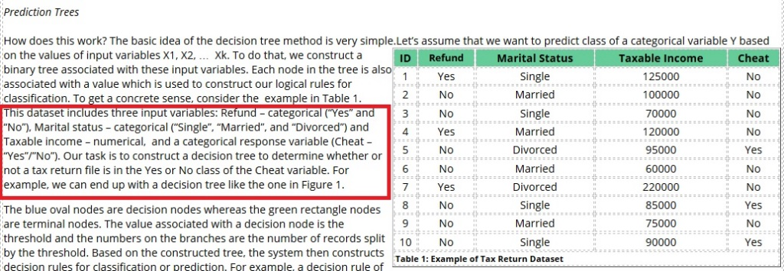
 | - Use Summary/Alt text. | Option b. Right click in the table. Select Table Properties and select the Advanced tab. Enter the explanantion in the Summary field.  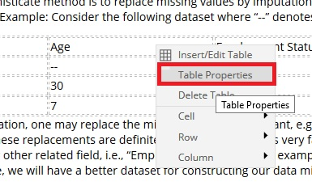  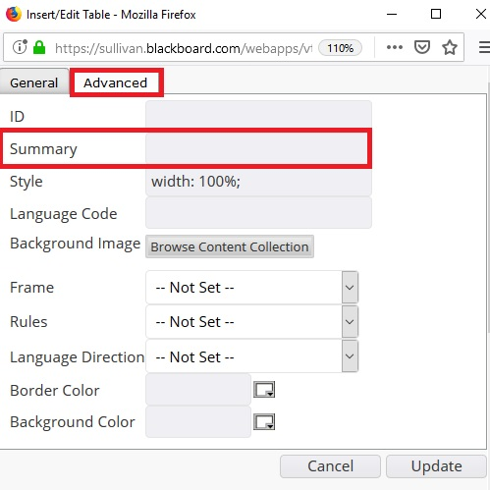
 | 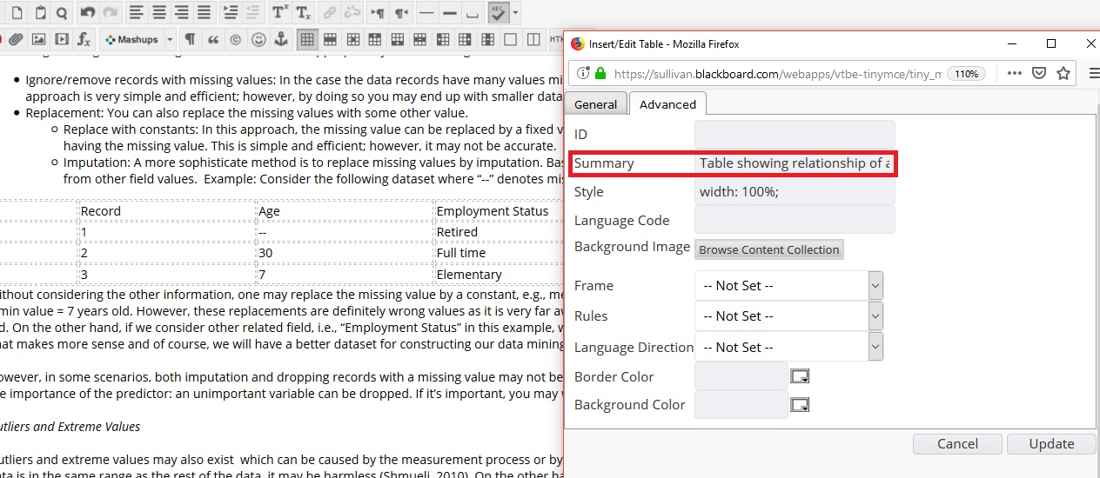
7. | In the table, designate the header row.  - With the table highlighted, right click and go to Table Properties>Row tab  - To designate the row as a heading check “Repeat as header row at the top of each page”  Note: Use heading styles for the actual row and column heading text. | 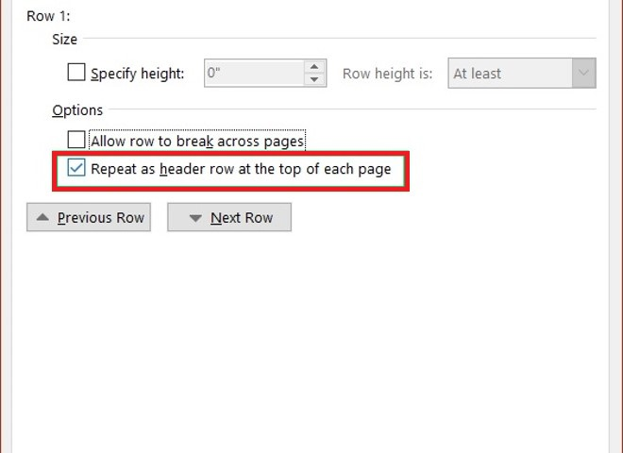
8. | Run accessibility checker.  - Select File>Check for Issues>Check Accessibility | 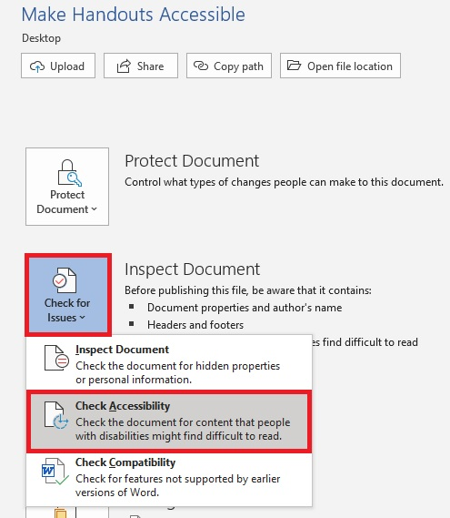
9. | Fix any issues identified in Accessibility Checker pane.  Note:  Word provides instructions on how to fix issues below the pane. | 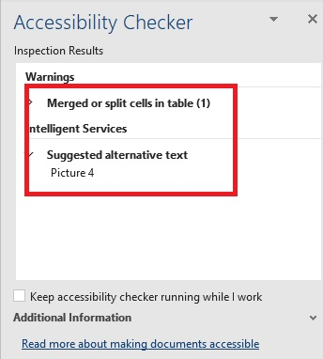
10. | Set file format.  - .doc and .docx may work best with readers  - .rtf retains most features and works with assistive tech  - Avoid .txt | 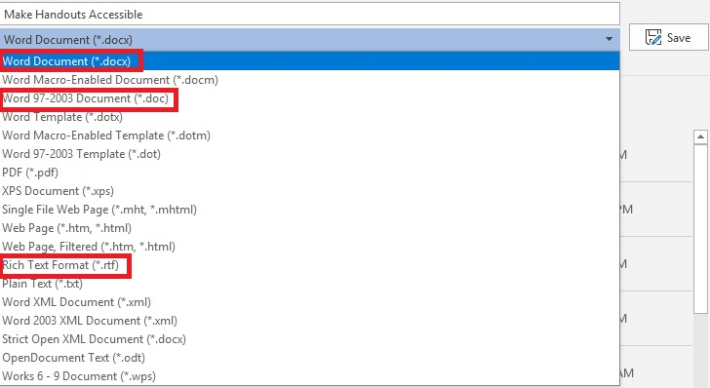
11. | Save your document.

