Step | Action | Graphic
1. | Select themes carefully. Not all themes have enough color contrast.  Note: Dark type on a light background or vice versa are best. | 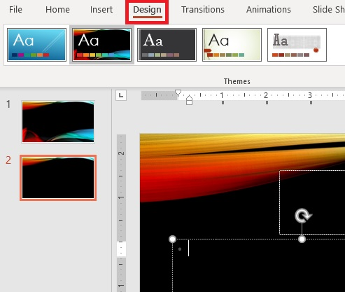
2. | Use slide templates that are already accessible to readers.  E.g., ‘Two Content” when you need columns.  Note: Use the simplest layout to convey relationship. | 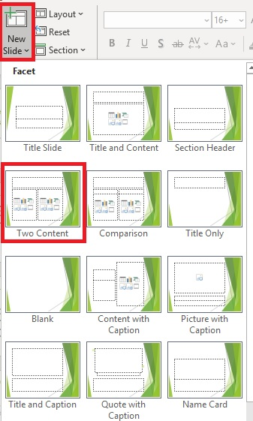
3. | Set font styles. We recommend doing this in Slide masters.  - Select san serif font such as Arial or Verdana  - Font size never less than 12 pt | 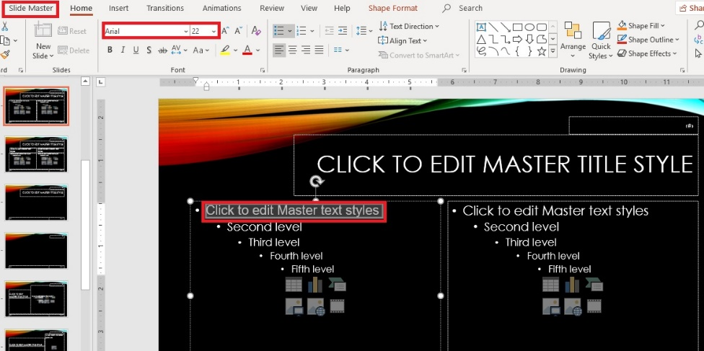
4. | Use 6 by 6 rule but avoid excessive brevity.  Note: This may lead to removing words to fit. Remember you can use the Slide Notes to elaborate! | 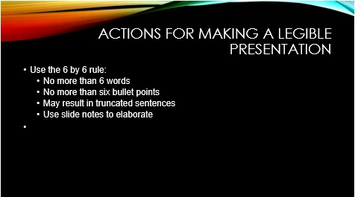
5. | Use adequate white space. Use Line spacing to add space between text. | 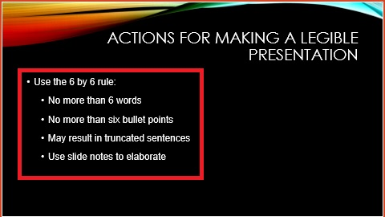
6. | Do not use features just because they are there. Use them to draw attention or keep focus if warranted. | Best practice is to avoid:  - Added text boxes  - Animations (can cause readers to crash)  - Slide transitions  - Automatic timing (let reader decide pace)  Note: Hyperlinks/buttons (do not work with readers).  Important Point: Most screen readers do not recognize bold or italics for emphasis. Use a verbal cue like “Note…” or “Important info…” or “Key Point…” as the screen reader will read those words.
7. | Thoroughly discuss slides’ content/words in any audio narration.  Provide a transcript of the narration/actual script of words. | Note: Screen readers can read/vocalize text on slides including alt text for images, but Audio narration…not so much.  Consider putting elaboration into ‘Notes’ and save/link to a version as a handout (not just saving as slide show).
8. | Check for accessibility.  - Select File>Check for Issues>Check Accessibility | 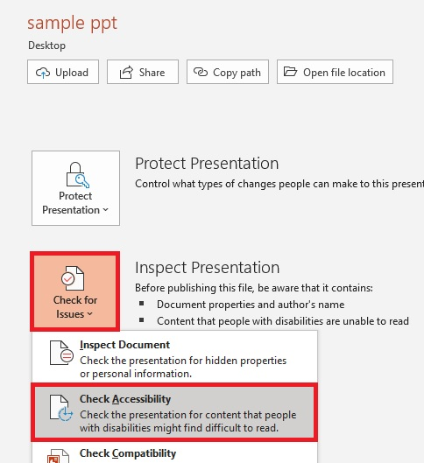
9. | Fix accessibility issues.  Note: Word provides instructions on how to fix issues below the pane. | 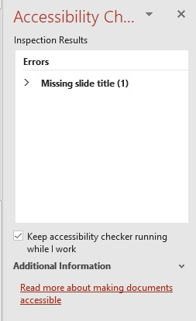
10. | Select file format.  .ppt and .pptx work best if you use the built in accessible features and tips | 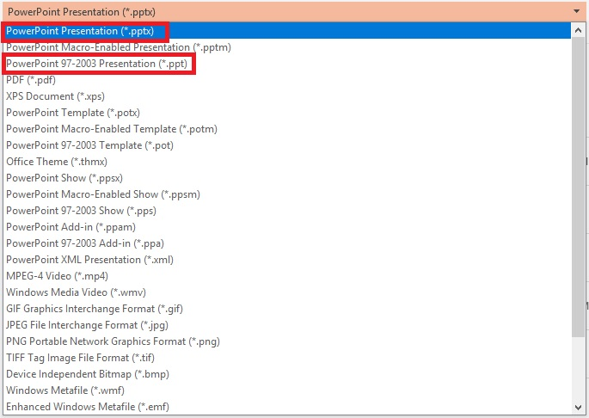
11. | Save your file.

