Step | Action | Graphic
Creating document in Word first:
1. | If creating in Word and saving as pdf file you must check the items that makes the document accessible to reader software.  Note: Ensure you run the Accessibility check in Word before saving as a pdf. | 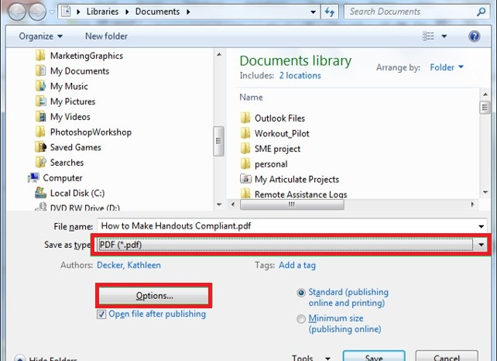
2. | Select accessibility items:  - Document structure tags for accessibility  - PDF/A compliant | 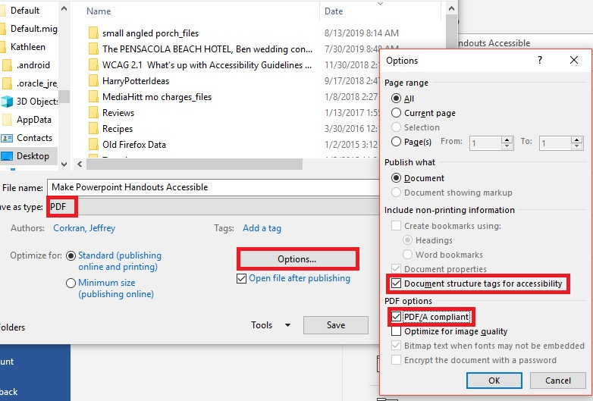
3. | Click OK, then Save.

Checking a Document’s Accessibility After Saving as a PDF in Acrobat Pro:
 | From an open pdf file, click Tools. | 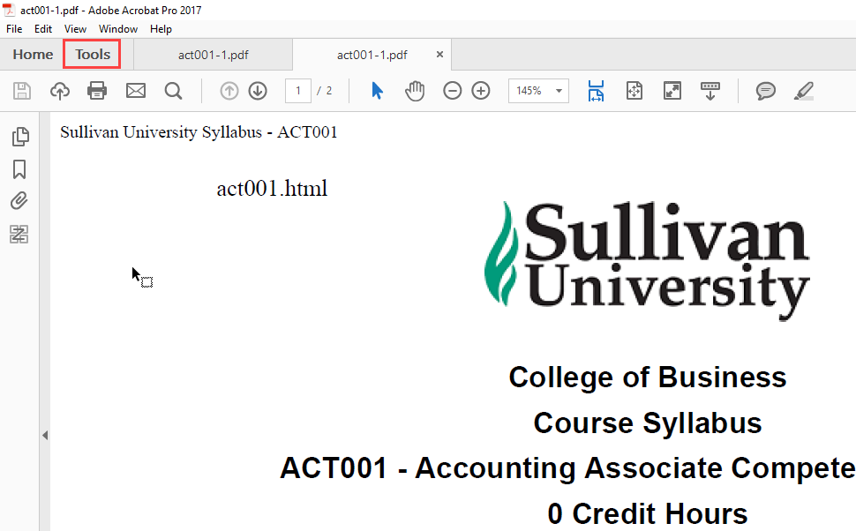
 | On the Tools page, scroll down and click Accessibility. | 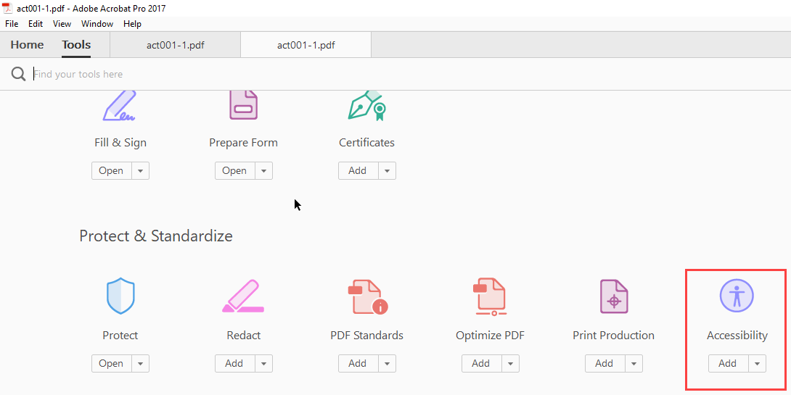
 | On the right-side panel that opens, click Reading Order. | 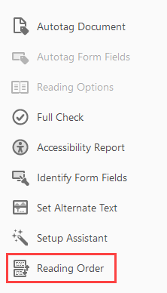
 | Use this tool to ensure the document is in the correct reading order. You draw a rectangle around content and then can designate it as a Header, a paragraph, a table, etc. or fix the item if it is not correct after your conversion.  Note: There is Help embedded in the tool. | 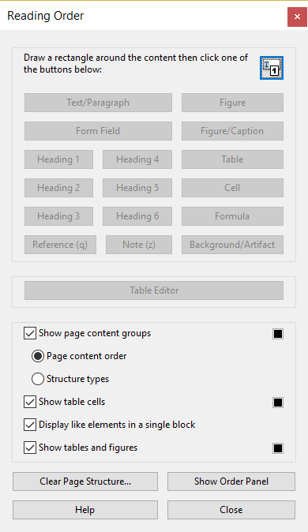
 | You can also select Show Order Panel. | 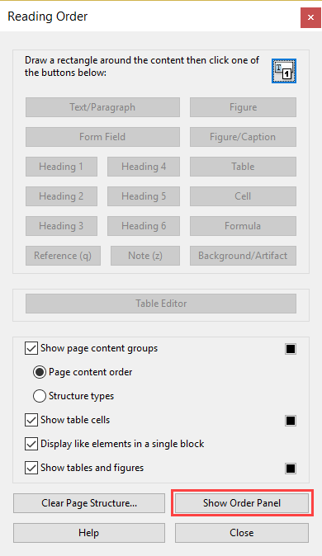
 | This shows you the order of pages and images. | 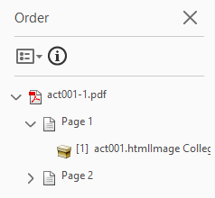

Using Acrobat Pro Accessibility Wizard
 | From an open pdf file, click Tools. | 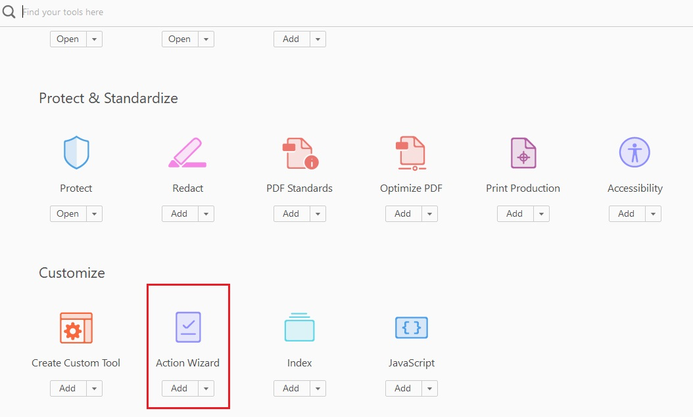
 | Select Make Accessible. | 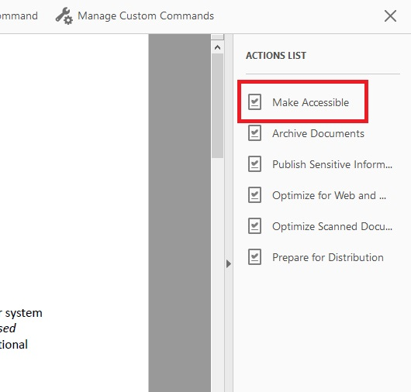
 | Select Start and follow the prompts to complete your review. | 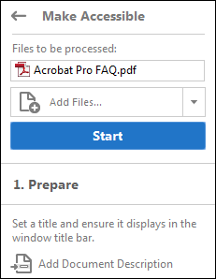
For more assistance visit Create and verify PDF accessibility (Acrobat Pro)

