Note: Excel interfaces well with screen readers.
Step | Action | Graphic
1. | Place cursor in first cell. Select Name Manager. | 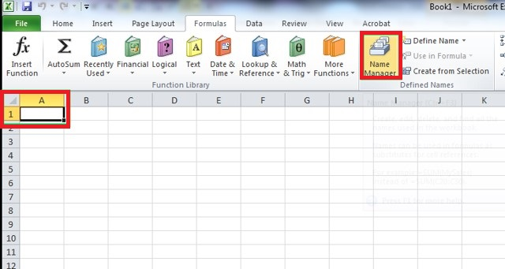
2. | Tag first cell as Title. It then knows this is the row and column titles. Click OK. | 