From Outlook 365
Step | Action | Graphic
1. | Open Outlook calendar. Select your day and time.  You may use the arrows to expand the meeting dialog box. | 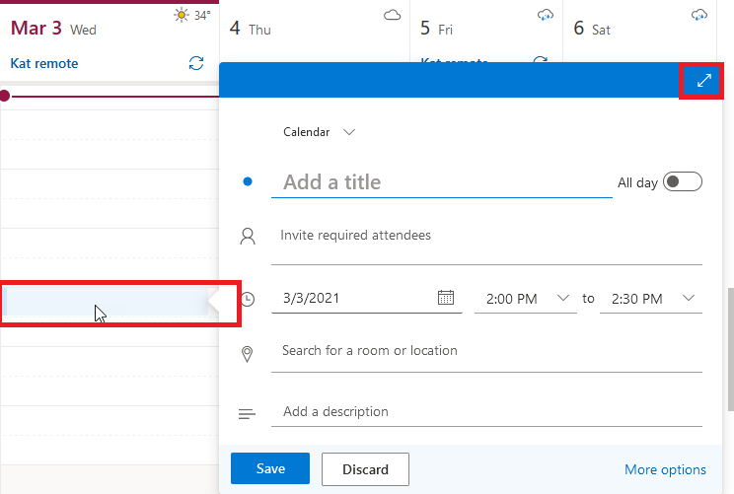
2. | Add your own meeting title, invite attendees, and verify the date and time of the meeting. | Enter basic info, title attendees date time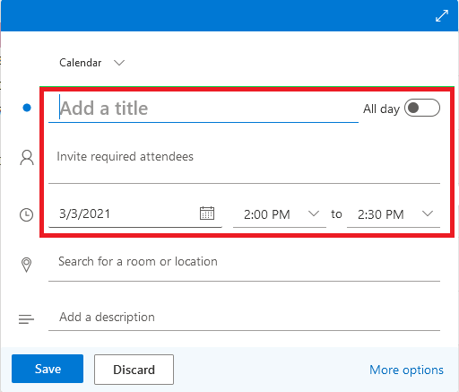
3. | Verify your meeting data. | 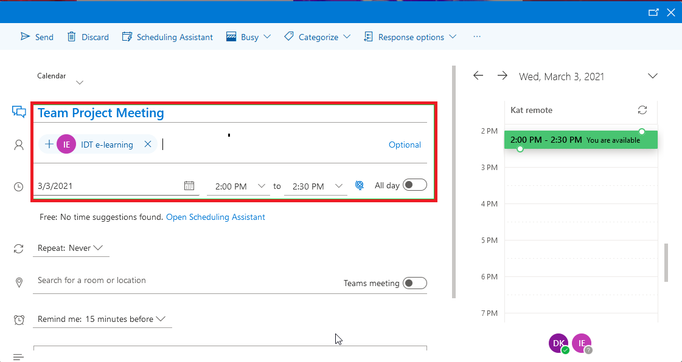
4. | Toggle the Team Meeting button. | 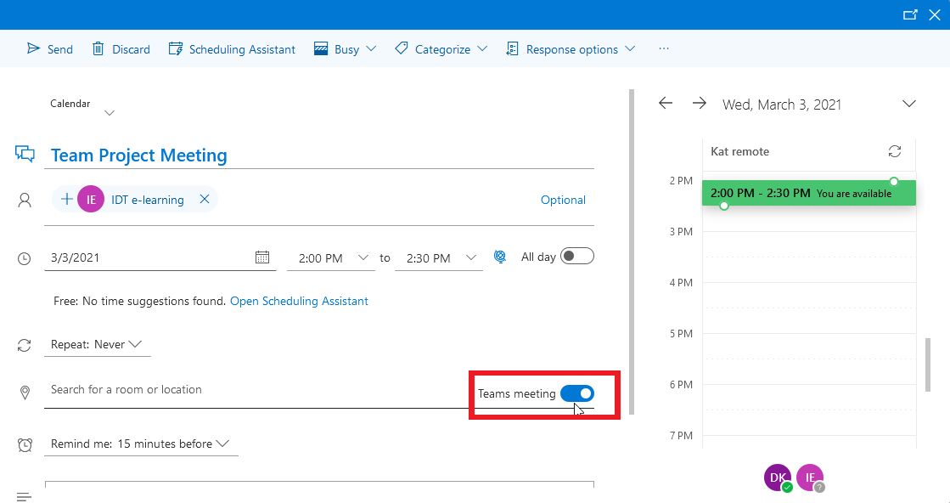
5. | Select your Response options from the toolbar dropdown menu. | 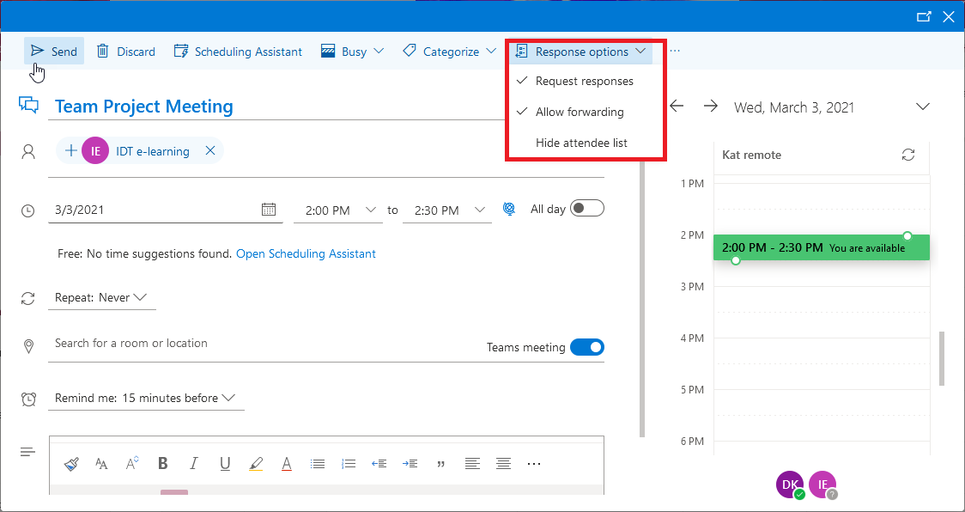
6. | Send your meeting invitation. | 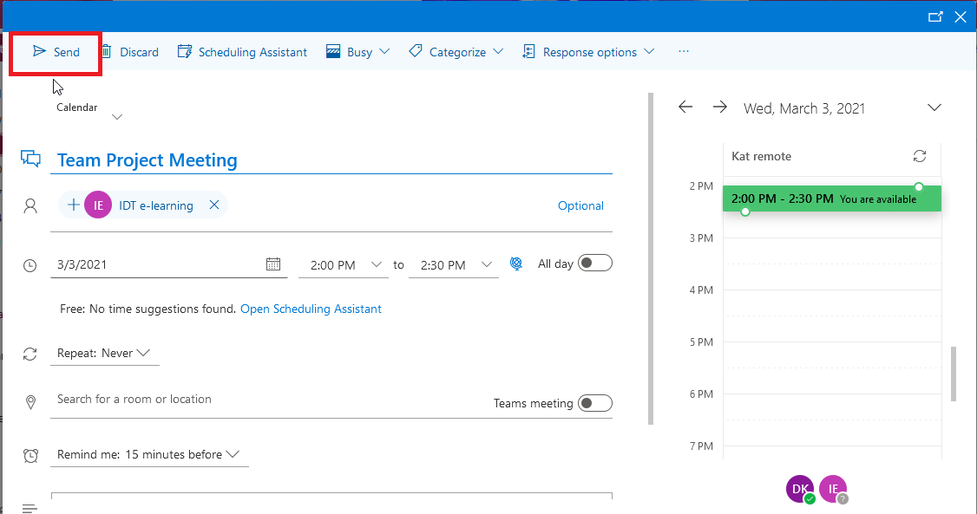
7. | Once saved, you may still make adjustments to the meeting invitation.  Once you verify all meeting parameters, copy the Microsoft Teams meeting links for the next step. | 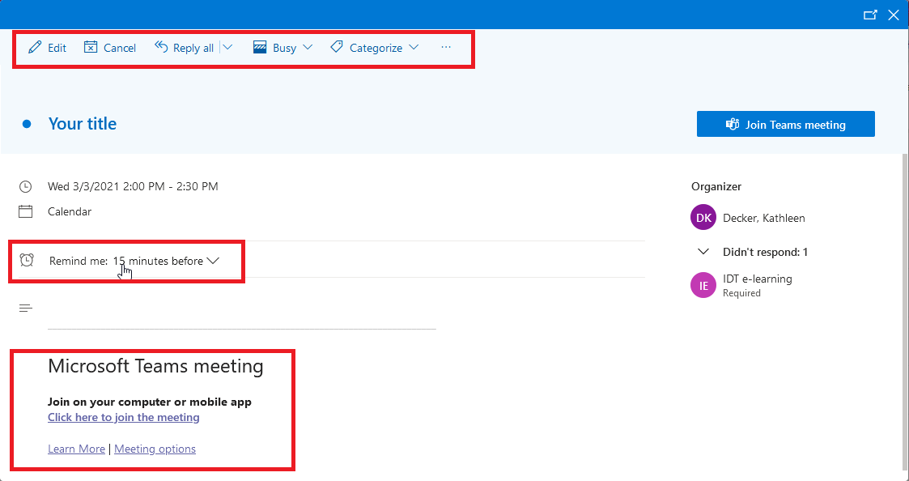
8. | Go to your related class where the meeting is to be accessed by students.  Go to Announcements>Create Announcement. | 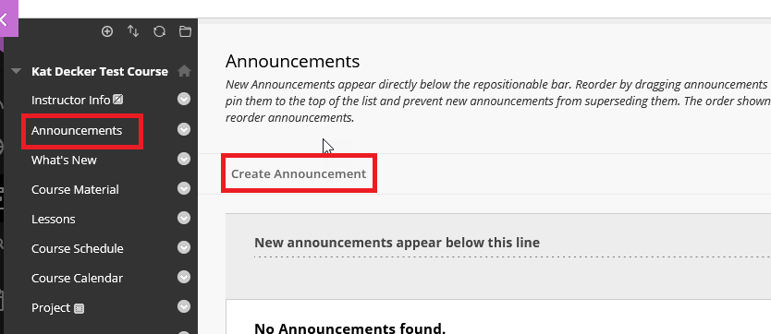
9. | Paste the Teams Meeting link into the announcement. | 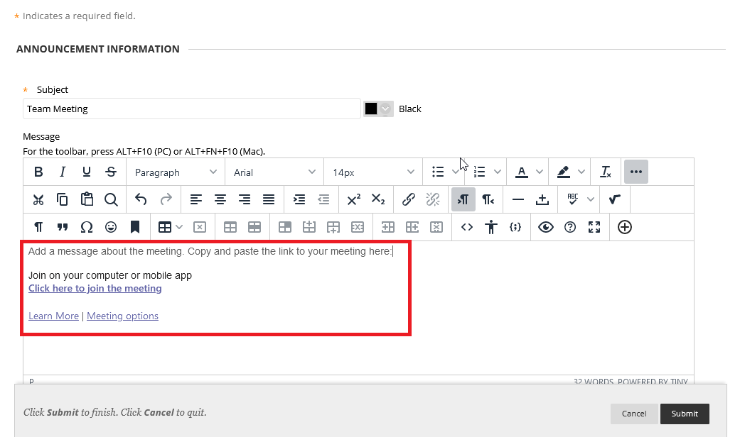
10. | When students click the link in your announcement, the Teams Meeting will open. Ensure your audio and video is set up as you desire. | 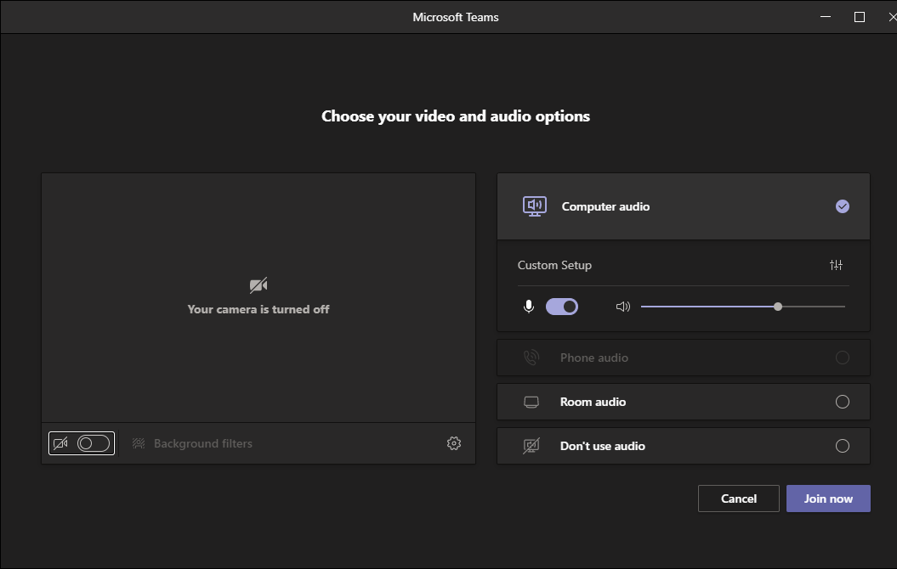

From Outlook Desktop App
Step | Action | Graphic
1. | From the Outlook Calendar select the New Teams Meeting button. | 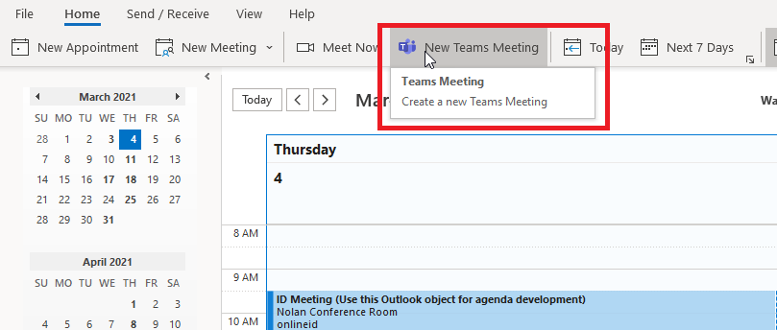
2. | Add your own meeting title, invite attendees, and verify the date and time of the meeting. | 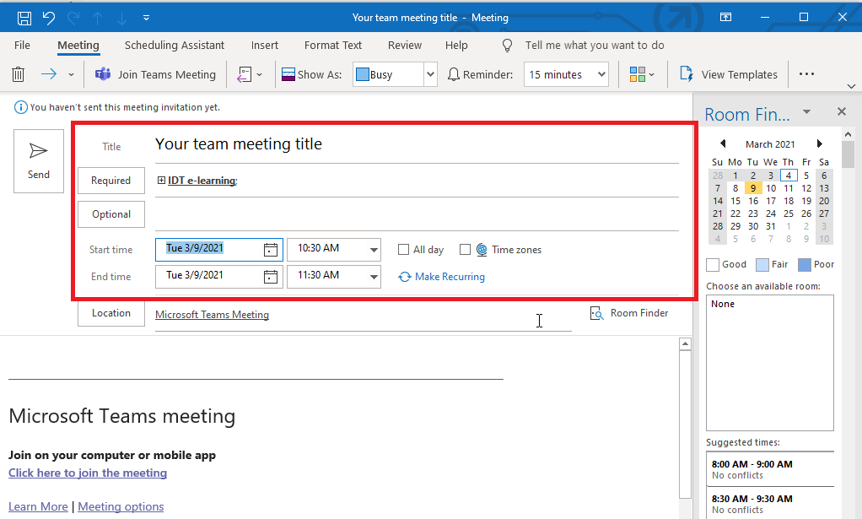
3. | Select your Response options from the toolbar dropdown menu. | 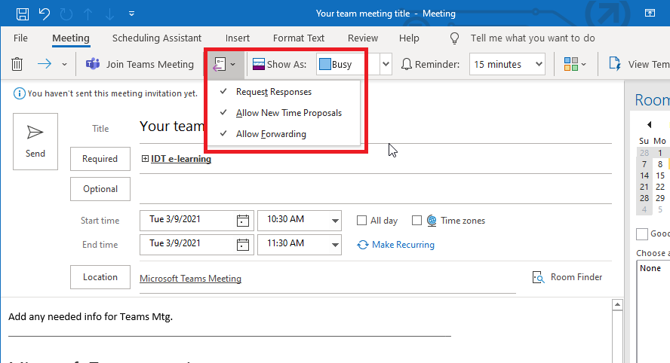
4. | Use either method to set up your recurrences if required. The Appointment Recurrence dialog box opens. | 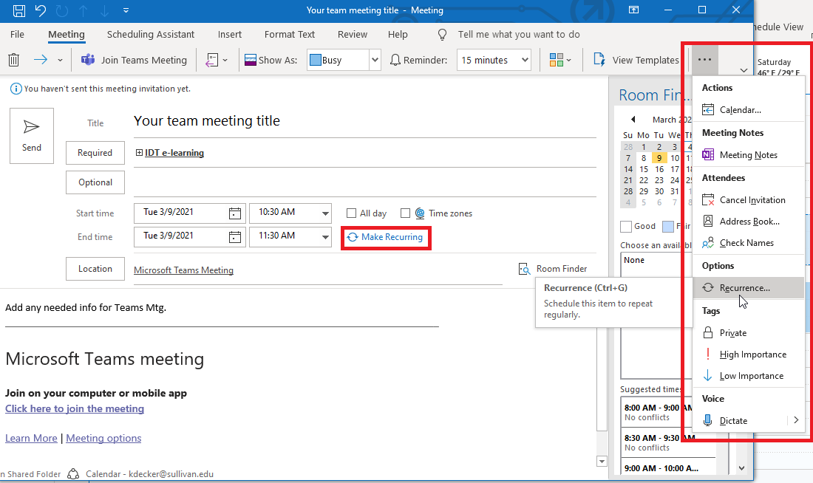
5. | Set up your recurrence pattern as required. | Set up recurrence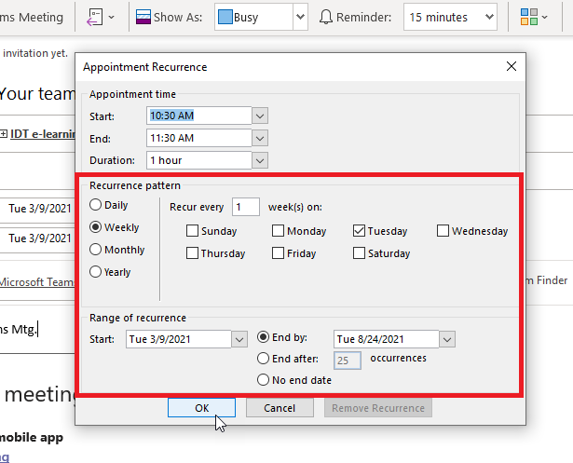
6. | Send your invitation. | 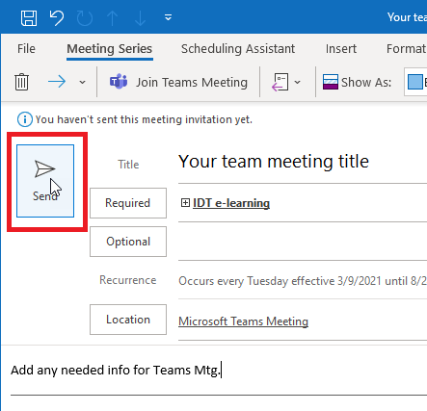
7. | Your Teams meeting is now on your calendar. | 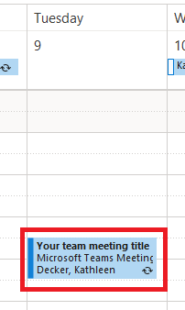
8. | Once you verify all meeting parameters, copy the Microsoft Teams meeting links for the next step. | 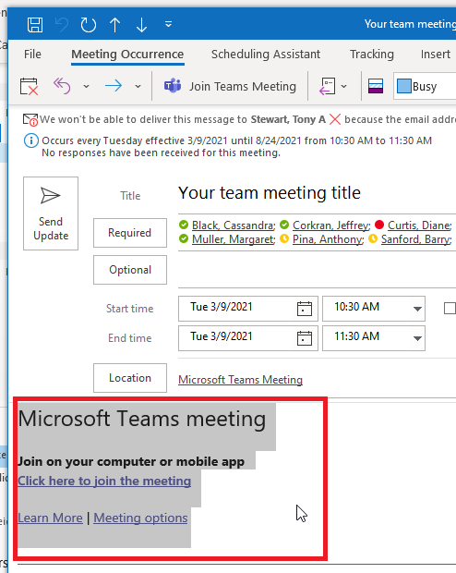
9. | Go to your related class where the meeting is to be accessed by students.  Go to Announcements>Create Announcement
10. | Paste the Teams Meeting link into the announcement.
11. | When students click the link in your announcement, the Teams Meeting will open. Ensure your audio and video is set up as you desire.

