Access Meeting Options Before a Meeting

Step | Action | Graphic
1. | Once you have created a Teams meeting in your Outlook calendar and sent out the meeting invite, click on the meeting you just created, and select Meeting options. | 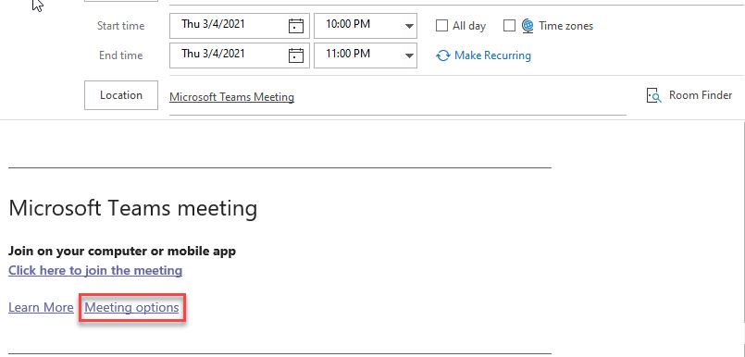
2. | Click on the arrow to access the pull-down menu and choose who can bypass the lobby. When this setting is enabled, people calling in by phone can join your meeting without having to wait for someone to admit them. | 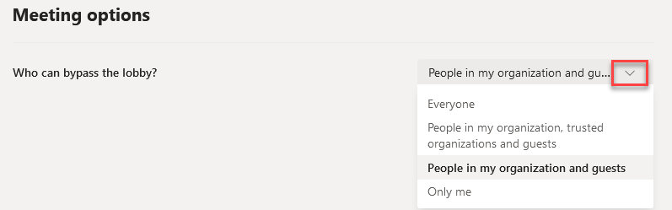
3. | Choose Yes or No for Always let callers bypass the lobby and  Announce when callers join or leave.
4. | Click on the arrow to access the pull-down menu and choose who can present during the meeting.
5. | Choose Yes or No for Allow attendees to unmute.
6. | Click on the arrow to access the pull-down menu and choose to enable or disable the meeting Chat.
7. | Choose Yes or No for Allow reactions.
8. | Click Save | 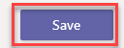

Access Meeting Options During a Meeting
Step | Action | Graphic
1. | During a meeting, you can access the same options listed above by clicking on the three dots to access More Actions and choosing Meeting Options. | 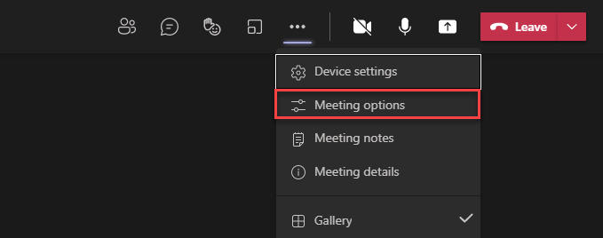
2. | After choosing your options, click Save.

