During class, create, deploy, and see results of a poll.

Create a Poll
1. | Within a Teams meeting, click the Show conversation icon.  Teams opens a Meeting chat panel. | 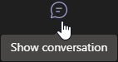
2. | Click the 3-dot … Messaging extensions icon. | 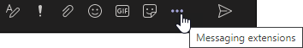
3. | Click Forms.  If Forms is not present, look under | 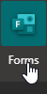
4. | Complete the poll form, then click Save. | 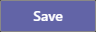
5. | Click Edit to continue editing the poll or Send to deploy the poll.
6. | The poll displays in the Chat panel, where students submit their responses. Below the poll, the panel displays the results tally in real time. | 