Use breakout rooms to put students into small groups during a synchronous class meeting. The students will already be logged into Teams for the class session. When you are ready to send the students into breakout rooms ...
1. | Click Breakout rooms on the Teams meeting toolbar. | 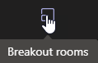
2. | Choose the number of rooms you want to create. | 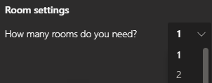
3. | Choose one of the two ways to assign students to breakout rooms.  - Automatically - Teams assigns participants to the number of rooms you specified, as equally in number as possible,  - Manually - You assign students to rooms on the next screen. | 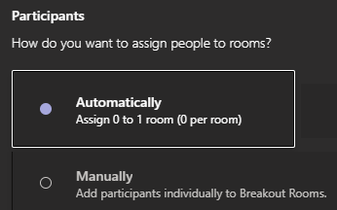
4. | Click Create rooms.
5. | If you opted to assign students manually, click to select students who will share the first breakout room you set up. | 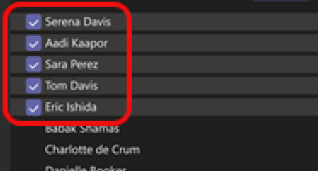
6. | Click Assign.
7. | Repeat Steps 5 and 6 until you have assigned all students to rooms.

